Review of Water Thresholds - Gnangara

Christopher Kavazos, Grant Buller, Pierre Horwitz, Ray Froend

‘r Sys.Date()’

# Introduction

This report details an analysis that reviews the ecological impacts of revised proposed water level thresholds for wetlands in the Gnangara mound.

Full analysis can be found at (<https://github.com/ChrisKav/DWER-Thresholds-2019>)

# EMP 173

Five year summaries of surface water level data at EMP 173

| Period | Mean max seasonal level (mAHD) | Mean min seasonal level (mAHD) | Mean seasonal change (m) | Month of maximum | Month of minimum | Mean max to min (days) |
| --- | --- | --- | --- | --- | --- | --- |
| 08/1994 - 07/1999 | 51.122 | 50.209 | 0.913 | October | March | 195.667 |
| 08/1999 - 07/2004 | 51.086 | 50.410 | 0.676 | September | April | 157.600 |
| 08/2004 - 07/2009 | 51.036 | 50.410 | 0.626 | August | January | 79.000 |
| 08/2009 - 07/2014 | 50.732 | 50.400 | 0.332 | October | February | 60.800 |
| 08/2014 - 07/2019 | 50.804 | 50.400 | 0.404 | September | January | 85.600 |

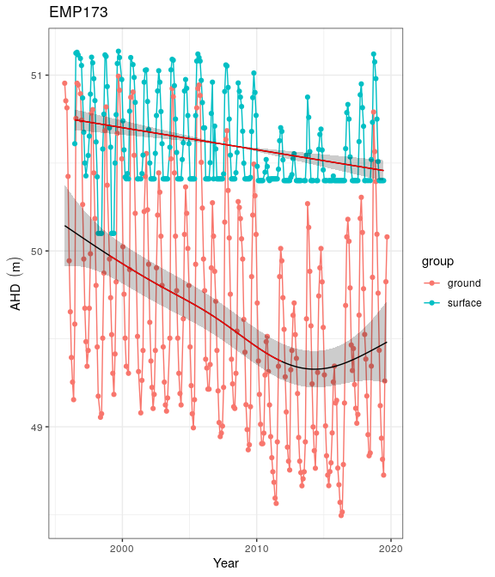

Ground and surface water levels recorded at bores and staff gauges in the vicinity of EMP 173

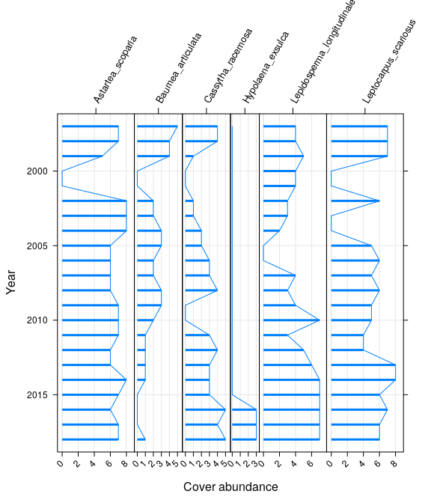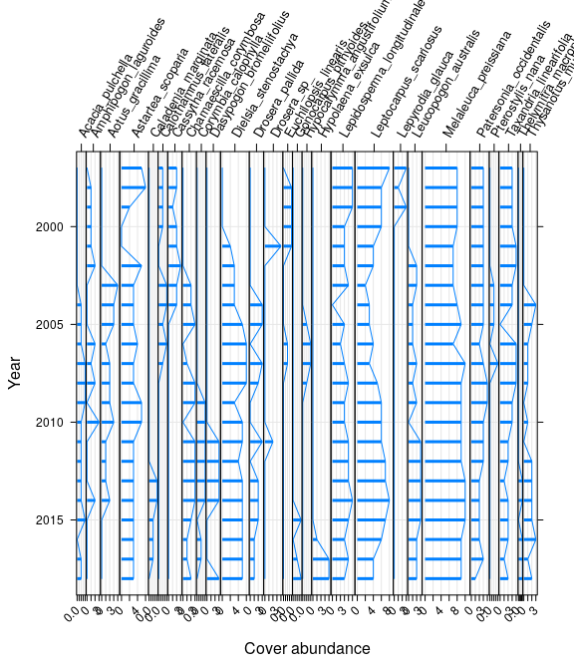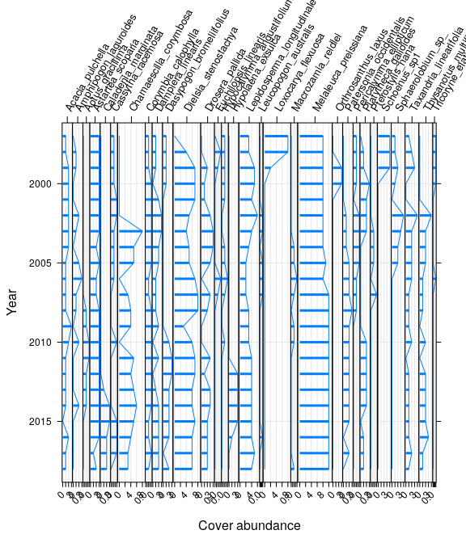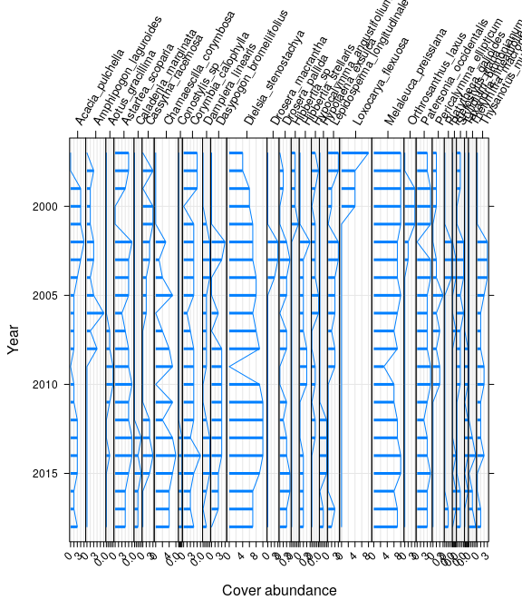

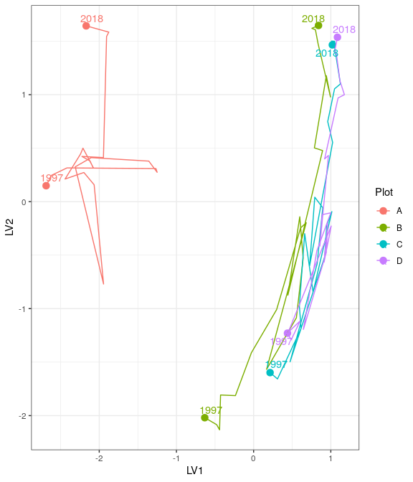

Ordination plot with full residual model on the left and a model on the right showing residual variation after the effect of groundwater levels were accounted for

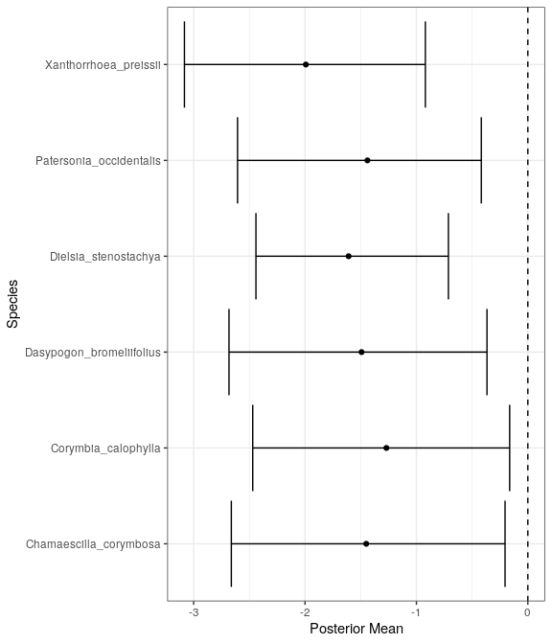

Mean regression coefficients (dots) and 95% credible intervals (bars) for effect of groundwater level on vegetation species cover abundances. Only those species with coefficients significanlty different to zero are shown

# EMP 78

Five year summaries of surface water level data at EMP 78

| Period | Mean max seasonal level (mAHD) | Mean min seasonal level (mAHD) | Mean seasonal change (m) | Month of maximum | Month of minimum | Mean max to min (days) |
| --- | --- | --- | --- | --- | --- | --- |
| 08/1994 - 07/1999 | 66.191 | 66.021 | 0.170 | July | June | -27.000 |
| 08/1999 - 07/2004 | 66.231 | 65.831 | 0.400 | October | May | 234.800 |
| 08/2004 - 07/2009 | 65.975 | 65.619 | 0.356 | November | April | 227.600 |
| 08/2009 - 07/2014 | 65.415 | 65.109 | 0.306 | October | July | 212.800 |
| 08/2014 - 07/2019 | 65.177 | 64.891 | 0.286 | November | May | 170.400 |

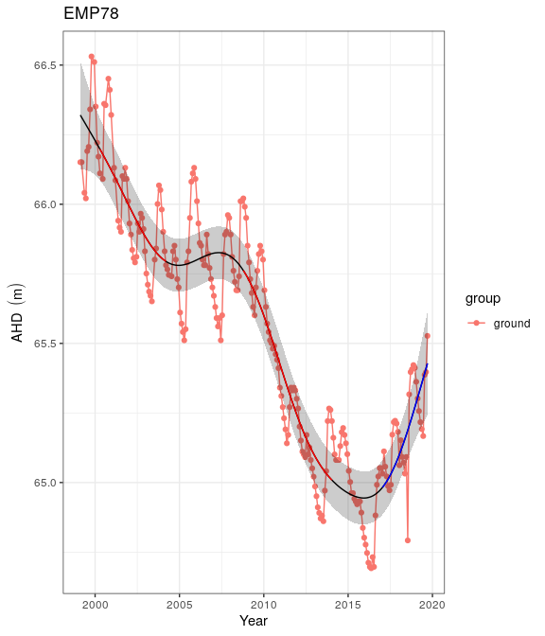

Ground and surface water levels recorded at bores and staff gauges in the vicinity of EMP 78

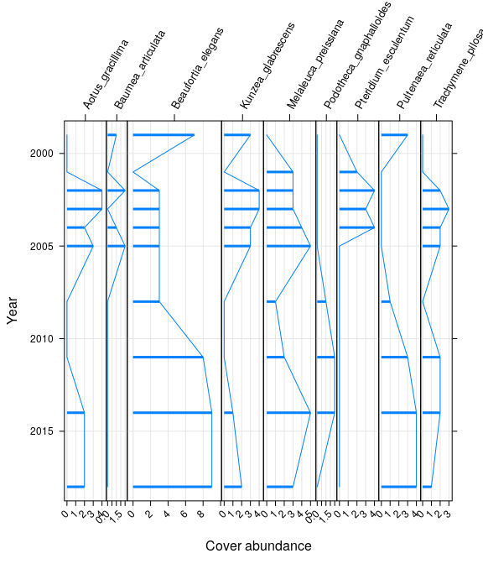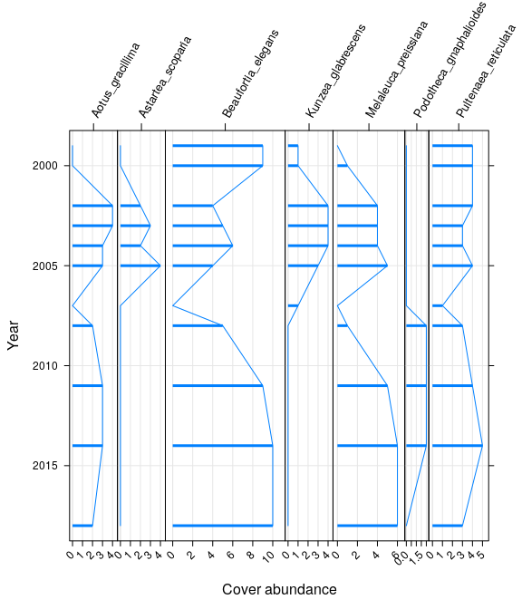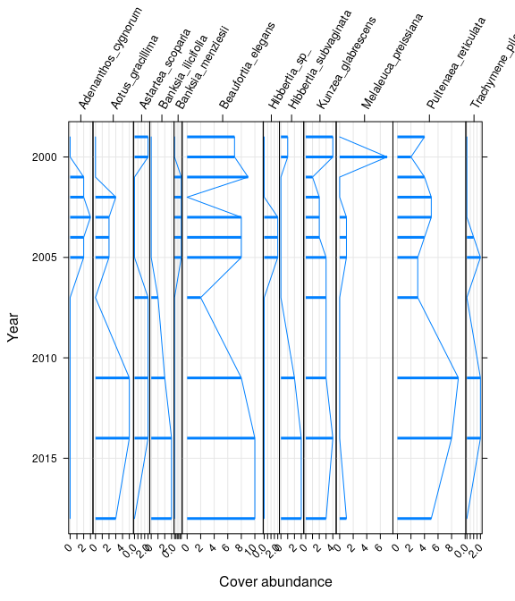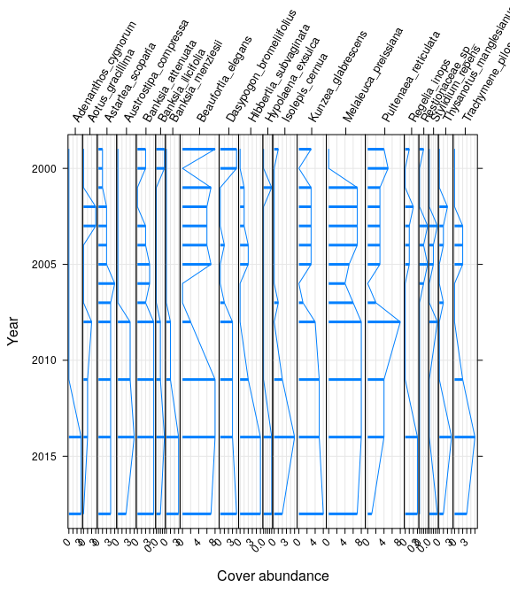

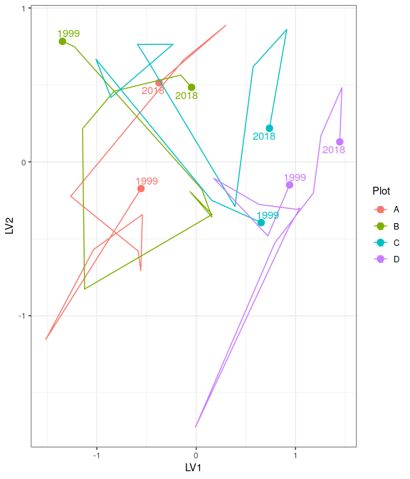

Ordination plot with full residual model on the left and a model on the right showing residual variation after the effect of groundwater levels were accounted for

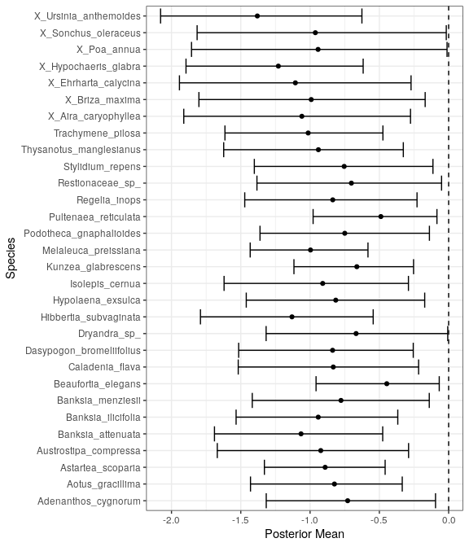

Mean regression coefficients (dots) and 95% credible intervals (bars) for effect of groundwater level on vegetation species cover abundances. Only those species with coefficients significanlty different to zero are shown

# Gingin

Five year summaries of surface water level data at Gingin

| Period | Mean max seasonal level (mAHD) | Mean min seasonal level (mAHD) | Mean seasonal change (m) | Month of maximum | Month of minimum | Mean max to min (days) |
| --- | --- | --- | --- | --- | --- | --- |
| 08/1994 - 07/1999 | 39.628 | 39.174 | 0.454 | October | July | 218.800 |
| 08/1999 - 07/2004 | 39.162 | 38.644 | 0.518 | December | May | 198.200 |
| 08/2004 - 07/2009 | 38.534 | 38.106 | 0.428 | October | June | 212.600 |
| 08/2009 - 07/2014 | 37.930 | 37.530 | 0.400 | October | May | 221.400 |
| 08/2014 - 07/2019 | 37.783 | 37.352 | 0.431 | November | May | 141.000 |

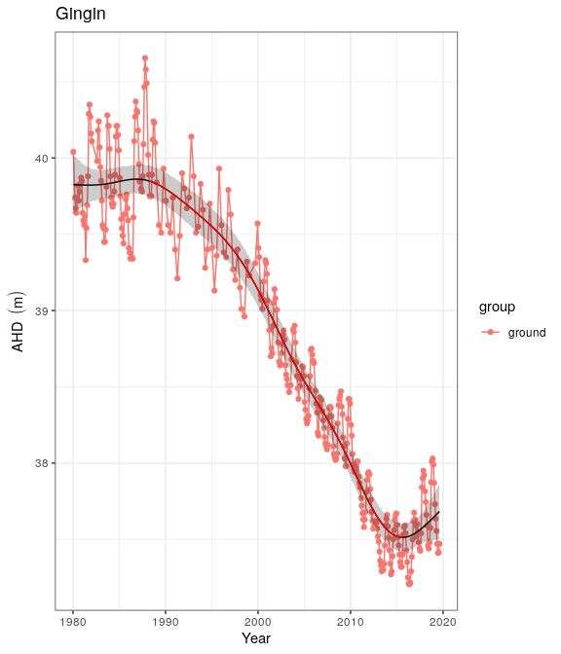

Ground and surface water levels recorded at bores and staff gauges in the vicinity of Gingin

# Lake Goollelal

Lake Goollelal, located within the Yellagonga Regional Park, is recognised as an important waterbird habitat and drought refuge (FROEND 2006) as well as habitat for the Swan River Goby (*Pseudogobius olorum*) and the Wetern Pygmy Perch (*Edelia vittata*) (WAWA 1995). The permanent deep waters found in the lake not only provides significant habitat for fauna and fringing vegetation, but also has significant value as a place of public enjoyment.

## Water levels

Surface water levels recorded at Lake Goollelal reveal peak levels generally occur between September and November and lowest water levels between March and May. There has been a consistent range of about 0.7 m in annual water level during this period. There has been a general trend of decreasing water levels since 1995 although recent increases since 2016 show surface waters at a similar depth to 1990 levels. Surface water levels show similar trends to groundwater levels at a nearby bore () as the lake is largely fed by groundwaters. Although the preferred minnimum threshold of 26.2 mAHD has not been breached, it is likely the threshold is set too low as the acidification of waters entering the lake is a concern (Quintero Vasquez 2018).

Five year summaries of surface water level data at Goollelal

| Period | Mean max seasonal level (mAHD) | Mean min seasonal level (mAHD) | Mean seasonal change (m) | Month of maximum | Month of minimum | Mean max to min (days) |
| --- | --- | --- | --- | --- | --- | --- |
| 08/1994 - 07/1999 | 27.534 | 26.754 | 0.780 | October | May | 206.800 |
| 08/1999 - 07/2004 | 27.485 | 26.684 | 0.800 | September | March | 206.400 |
| 08/2004 - 07/2009 | 27.379 | 26.628 | 0.751 | September | April | 137.400 |
| 08/2009 - 07/2014 | 27.244 | 26.513 | 0.731 | October | April | 189.600 |
| 08/2014 - 07/2019 | 27.386 | 26.708 | 0.678 | November | April | 138.600 |

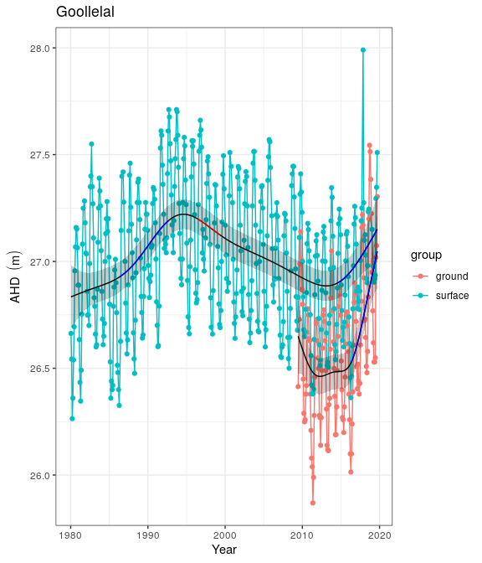

Ground and surface water levels recorded at bores and staff gauges in the vicinity of Goollelal

## Vegetation dynamics

The composition of vegetation at Lake Goollelal has been assesed 14 times between 1997 and 2014 at four plots [I NEED TO READ THE 2014 VEG REPORT]. Plot A represents fringing *Melaleuca rhaphiophylla*/*Eucalyptus rudis* complex and a stable community of the native sedges, *Baumea articulata* and *Lepidosperma gladiatum*. The *Melaleuca rhaphiophylla*/*Eucalyptus rudis* complex continues throughout the transect, which has also remained relatively stable in terms of cover abundance since 2002.

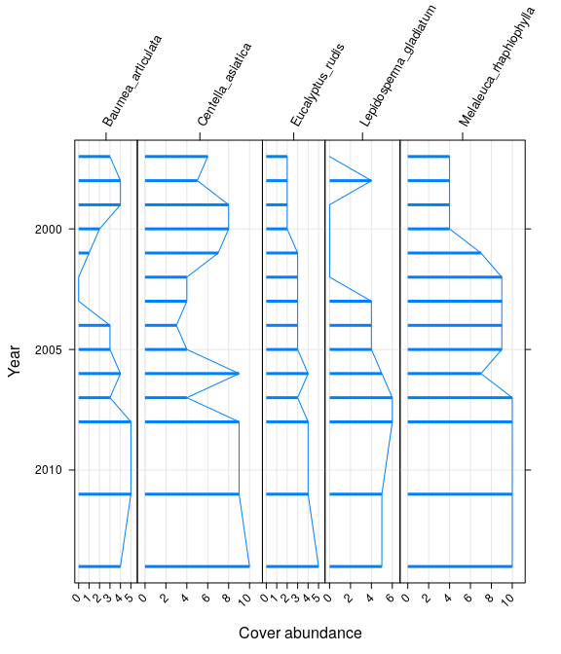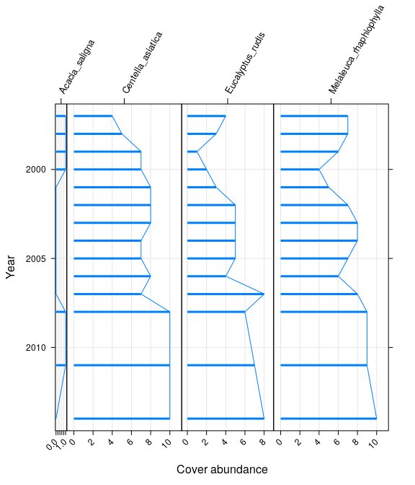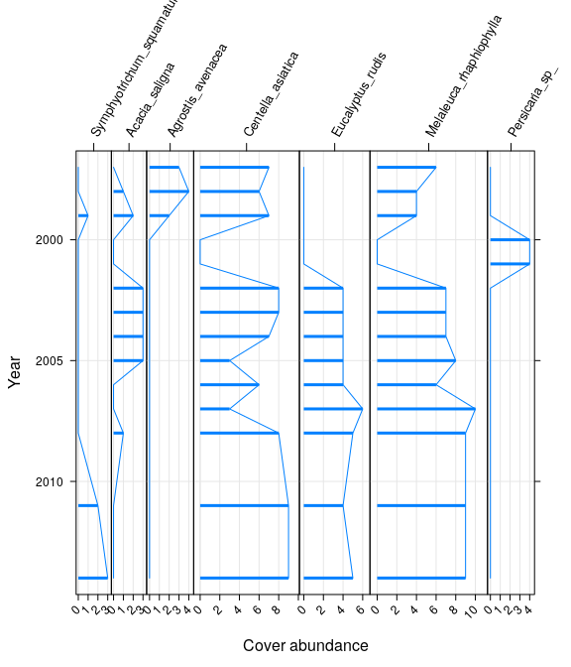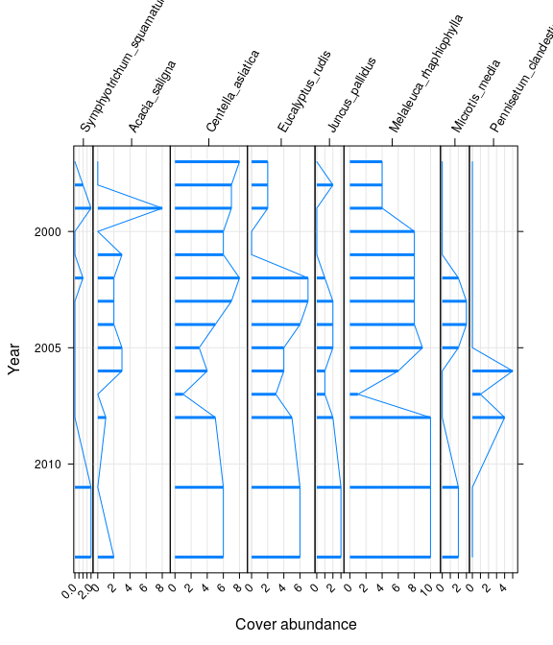

Ordination reveals that Plot A has a distinct assemblage to the other plots but has displayed similay vegetation compositional changes. Shifts in compositional change has followed similar trajectories for each of the plots. All plots show an initial shift in community cover abundance from the 1997 survey and a return to 1997-like composition in the recent survey years.

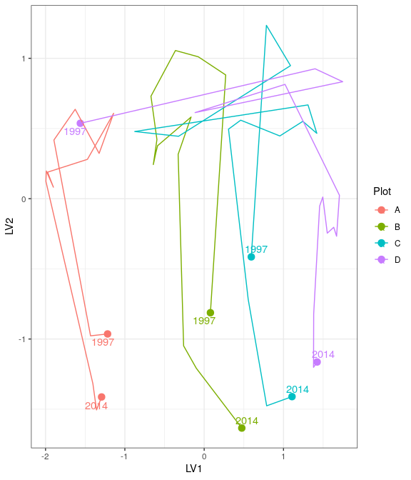

Ordination plot with full residual model on the left and a model on the right showing residual variation after the effect of groundwater levels were accounted for

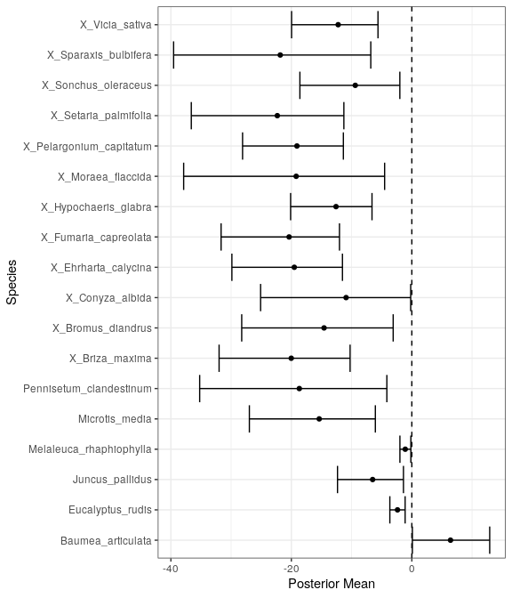

Mean regression coefficients (dots) and 95% credible intervals (bars) for effect of groundwater level on vegetation species cover abundances. Only those species with coefficients significanlty different to zero are shown

Ecological consequences of revised thresholds in terms of compliance of stated site values and site management objectives.

|  |  |  |
| --- | --- | --- |
|  | Likely effect of 2030 revised thresholds | Future Compliance |
| **Site values** |  |  |
| Waterbird habitat and drought refuge |  |  |
| Supports good populations of native fish species, Swan River goby (*Pseudogobius olorum*) and the western pygmy perch (*Edelia vittata*) |  |  |
| **Site management objectives** |  |  |
| Conservation and public enjoyment of natural and modified landscapes |  |  |
| Protect and if possible enhance, fringing wetland vegetation including woodland and sedge vegetation |  |  |
| Maintain permanent, deep water for waterbird habitat and as a drought refuge |  |  |
| Maintain permanent water for fish and other dependent species |  |  |
| Maintain the landscape amenity values of the wetland |  |  |

# Gwelup

Five year summaries of surface water level data at Gwelup

| Period | Mean max seasonal level (mAHD) | Mean min seasonal level (mAHD) | Mean seasonal change (m) | Month of maximum | Month of minimum | Mean max to min (days) |
| --- | --- | --- | --- | --- | --- | --- |
| 08/1994 - 07/1999 | 7.515 | 5.661 | 1.854 | September | April | 238.800 |
| 08/1999 - 07/2004 | 6.664 | 5.146 | 1.518 | October | April | 171.600 |
| 08/2004 - 07/2009 | 6.322 | 5.000 | 1.322 | September | December | 14.000 |
| 08/2009 - 07/2014 | 6.146 | 4.972 | 1.174 | October | January | 138.400 |
| 08/2014 - 07/2019 | 7.251 | 5.592 | 1.659 | October | April | 221.800 |

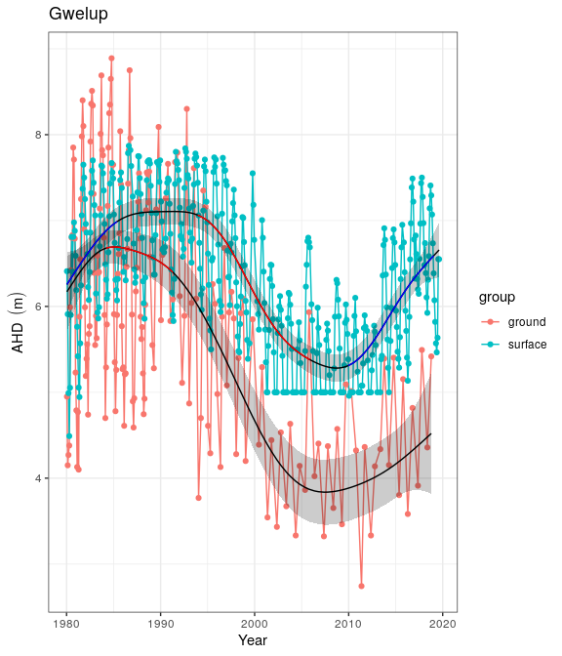

Ground and surface water levels recorded at bores and staff gauges in the vicinity of Gwelup

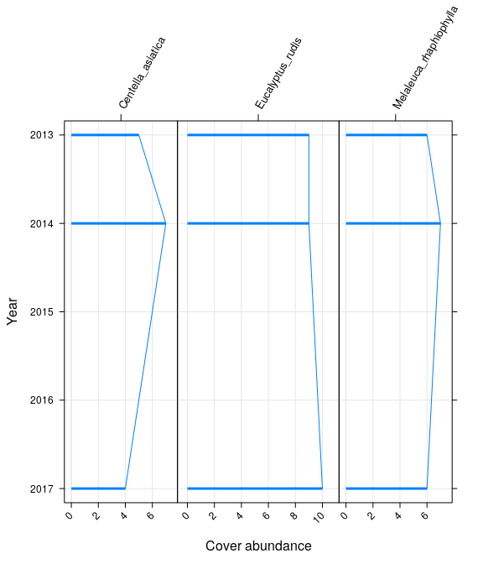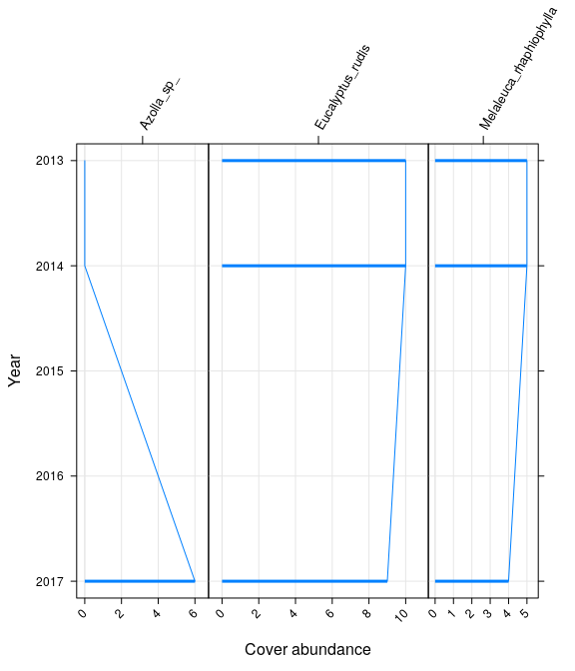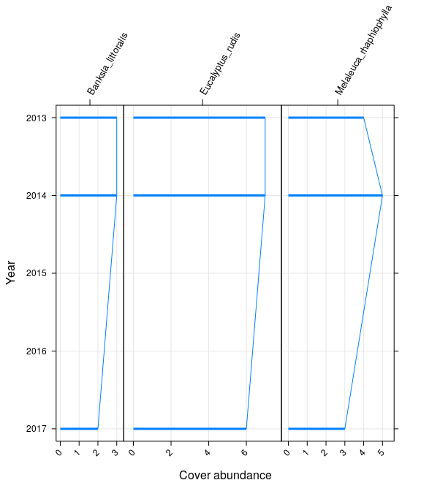

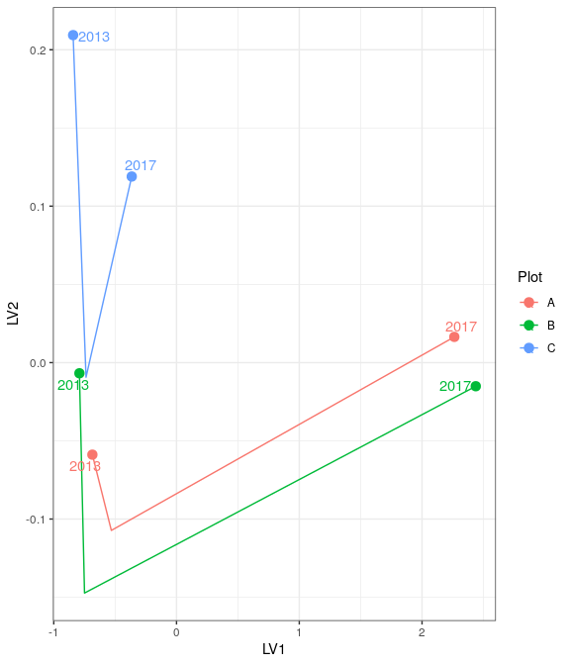

Ordination plot with full residual model on the left and a model on the right showing residual variation after the effect of groundwater levels were accounted for

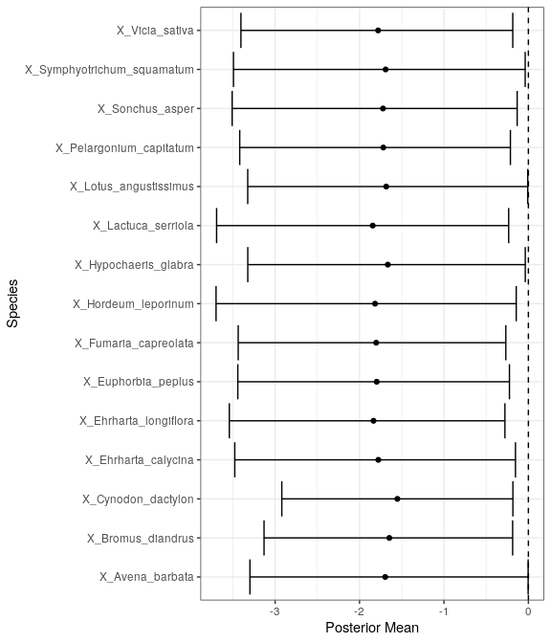

Mean regression coefficients (dots) and 95% credible intervals (bars) for effect of groundwater level on vegetation species cover abundances. Only those species with coefficients significanlty different to zero are shown

# Jandabup

Five year summaries of surface water level data at Jandabup

| Period | Mean max seasonal level (mAHD) | Mean min seasonal level (mAHD) | Mean seasonal change (m) | Month of maximum | Month of minimum | Mean max to min (days) |
| --- | --- | --- | --- | --- | --- | --- |
| 08/1994 - 07/1999 | 44.914 | 44.109 | 0.805 | October | February | 155.800 |
| 08/1999 - 07/2004 | 44.876 | 44.232 | 0.644 | September | March | 151.200 |
| 08/2004 - 07/2009 | 44.843 | 44.248 | 0.595 | July | March | 108.000 |
| 08/2009 - 07/2014 | 44.674 | 44.156 | 0.518 | October | January | 164.400 |
| 08/2014 - 07/2019 | 44.744 | 44.231 | 0.513 | September | March | 182.000 |

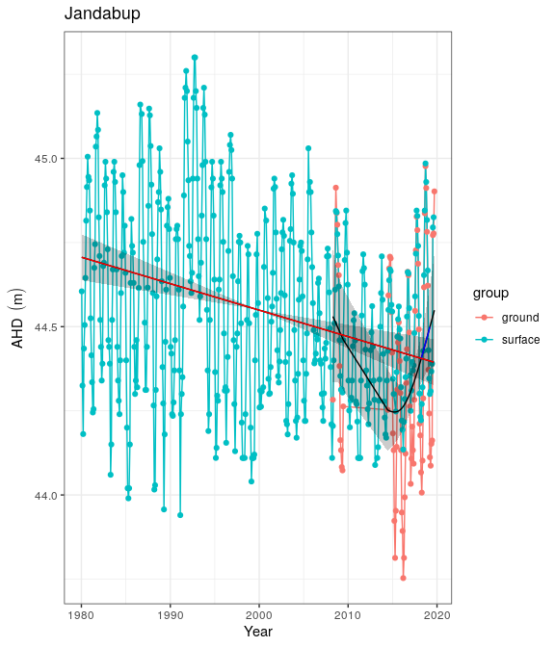

Ground and surface water levels recorded at bores and staff gauges in the vicinity of Jandabup

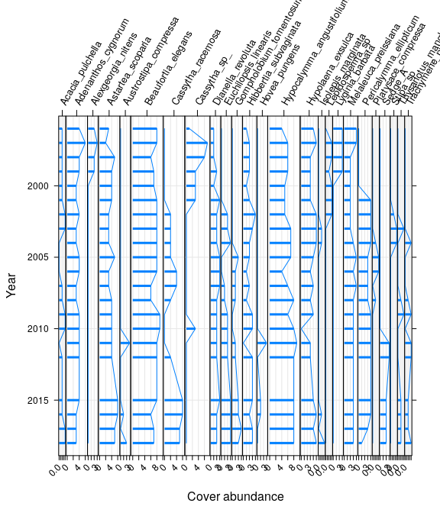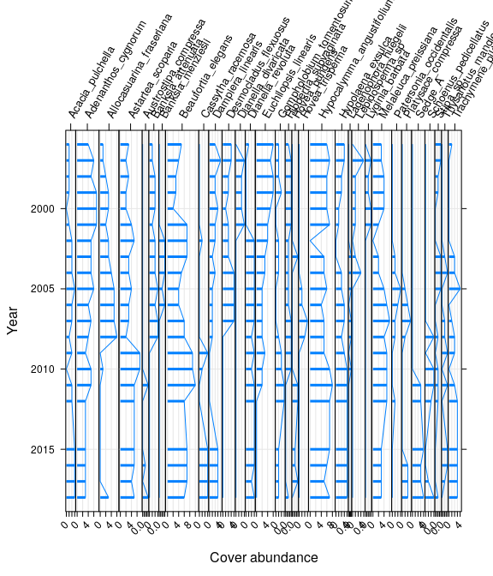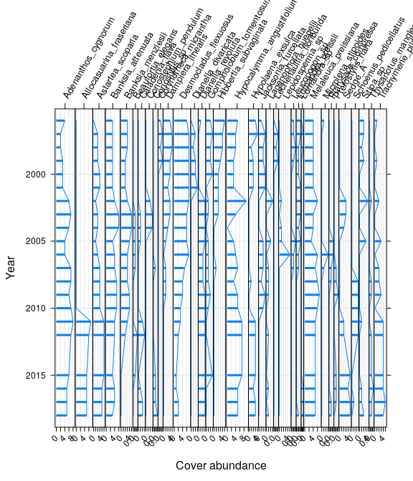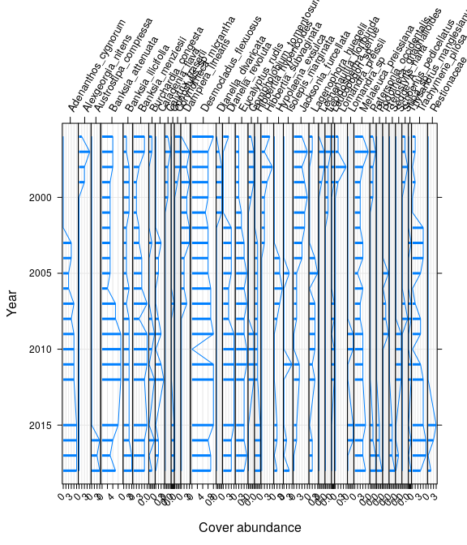

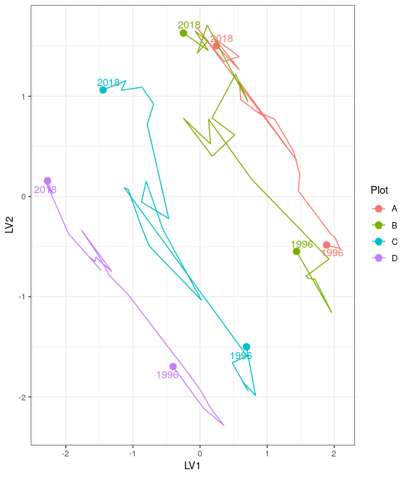

Ordination plot with full residual model on the left and a model on the right showing residual variation after the effect of groundwater levels were accounted for

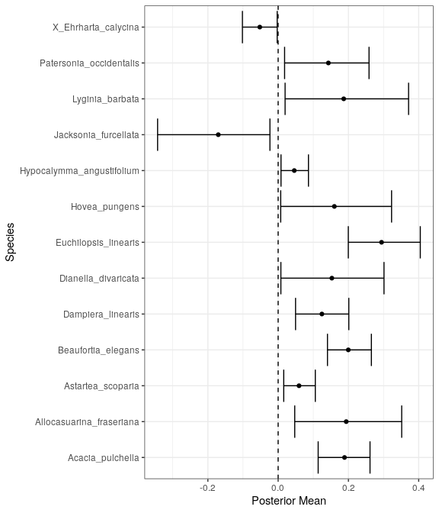

Mean regression coefficients (dots) and 95% credible intervals (bars) for effect of groundwater level on vegetation species cover abundances. Only those species with coefficients significanlty different to zero are shown

# Joondalup

At 611.5 ha, Lake Joondalup is the largest GMEMP monitored wetland and is managed by the Department of Biodiversity, Conservation and Attractions. The lake is an important habitat and drought refuge for water birds, and in conjunction with Lake Goollelal, is managed to support the full range of avian habitats (WAWA 1995). Other management objectives include the conservation of diverse wetland vegetation communities, including sedge beds, fringing woodlands and aquatic macrophytes, and the maintenance or enhancement of aquatic fauna in the lake. Lake Joondalup supports an important population of Pygmy Perch (Edelia vittata) and Swan River Goby (Pseudogobius olorum) and the fringing woodlands and bushland support a variety of significant mammal species.

## Water levels

Lake Joondalup has remained permanently inundated at the staff gauge [HOW DO I FIND THIS OUT] since 1986 (REFERENCE Chapter 5 Horwitz et al). However, vast regions of the basin dry most summers. Historically, groundwater levels at monitoring bore 61610661 declined significantly from 19.3 to 18.1 mAHD from 1970 to 2002 (Figure 1). Currently, groundwater levels at this bore, as well as bore 61611423 (likely to better reflect lake surface water variation), have been increasing since 2015 to levels similar to the early 1990?s. Recent monitoring of surface water levels at the staff gauge 6162572 remained relatively stable from 2002 but have been increasing from 16.4 mAHD to approximately 17.2 mAHD in 2019. Five-year summaries of hydrological regimes at Lake Joondalup also reveal the higher mean minimum and maximum surface water levels in the latest period compared to earlier periods, as well as an increase in the number of days to reach seasonal minimum water levels (Table 1).

Five year summaries of surface water level data at Lake Joondalup

| Period | Mean max seasonal level (mAHD) | Mean min seasonal level (mAHD) | Mean seasonal change (m) | Month of maximum | Month of minimum | Mean max to min (days) |
| --- | --- | --- | --- | --- | --- | --- |
| 08/1994 - 07/1999 | 17.184 | 16.225 | 0.959 | September | April | 213.400 |
| 08/1999 - 07/2004 | 16.980 | 16.064 | 0.916 | October | April | 179.400 |
| 08/2004 - 07/2009 | 16.916 | 16.123 | 0.792 | October | April | 181.000 |
| 08/2009 - 07/2014 | 16.884 | 16.064 | 0.820 | October | March | 172.800 |
| 08/2014 - 07/2019 | 17.162 | 16.483 | 0.679 | October | April | 205.800 |

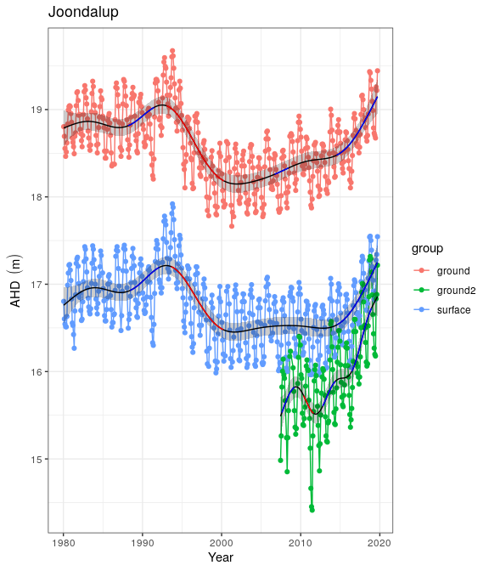

Ground and surface water levels recorded at bores and staff gauges in the vicinity of Joondalup

## Vegetation Dynamics

The recent increases in surface water levels has increased the pH from 6.8 in 2016 to 8.4 in 2018 and increased alkalinity to 206 mg/L. Recent nutrient levels have been decreasing. [I NEED THIS DATA TO ANALYSE TRENDS] Vegetation surveys have been conducted along two transect at Lake Joondalup (Figure 2 and 3). Both the northern and southern transects were established in 1996 and were last surveyed in 2015. Melaleuca raphiophylla dominates the overstorey of plots in the northern transect while exotic species are abundant in the understory vegetation. There has been an increasing trend in cover abundance of the exotics Bromus diandrus, Ehrharta longiflora, Euphorbia terracina, Fumaria muralis and Peargonium capitatum in recent years. Fires in 2003 reduced the canopy condition and abundance of M. raphiophylla in the southern transect, and despite the slightly higher cover abundance of native species, native and exotic species richness is equal along the transect. The site also contains healthy stands of Baumea articulate and Centella asiatica in the submerged regions of the transect.

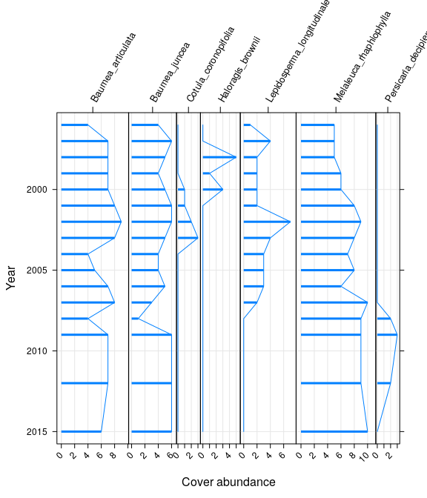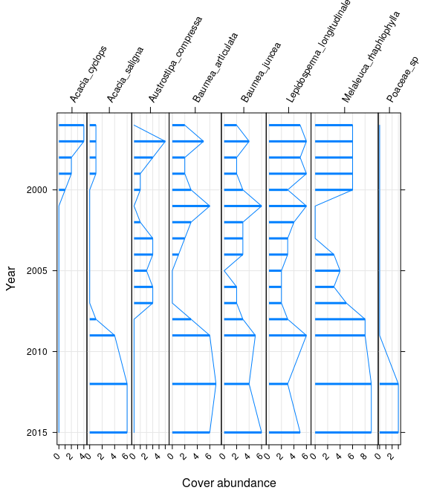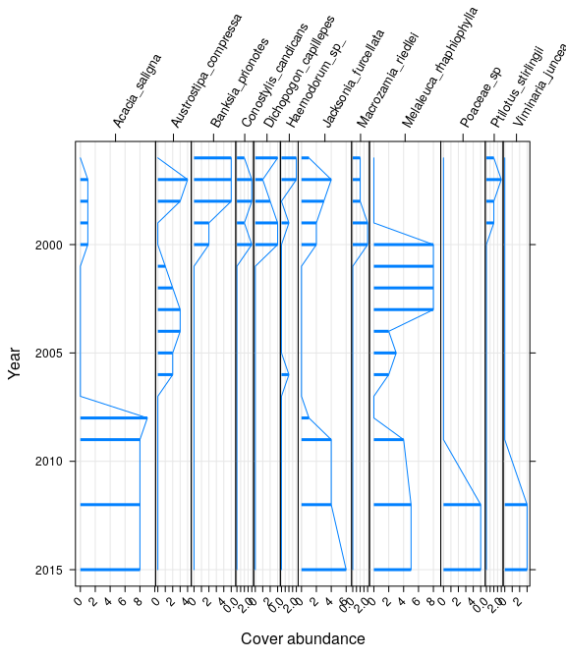

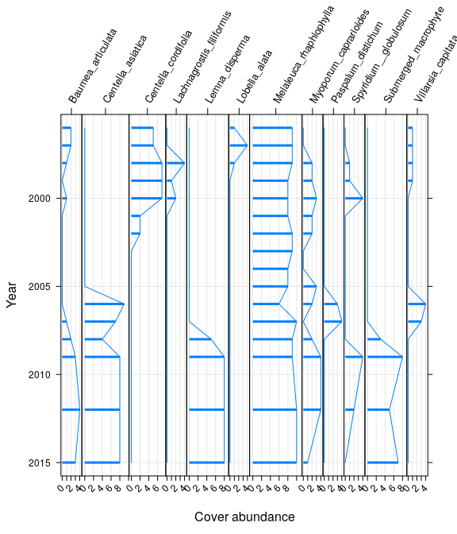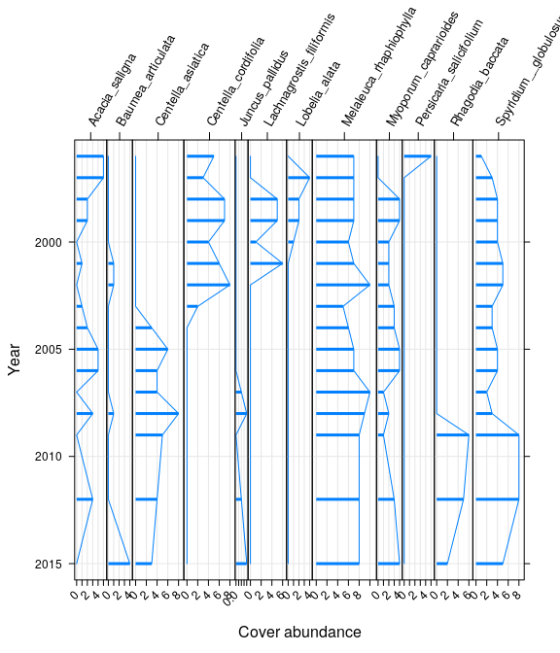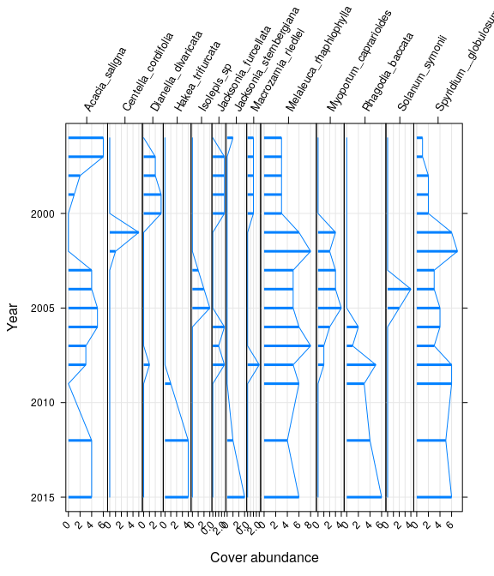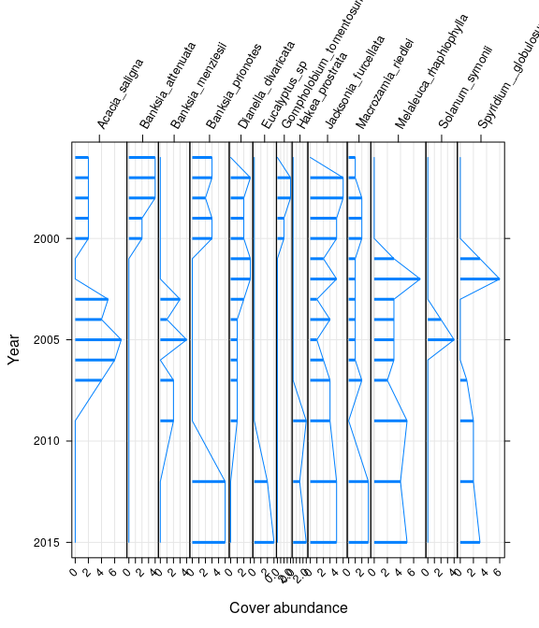

All plots in both transects have displayed similar trends in community compositional change during the survey period. In the southern transect, latent model ordination reveals separation of the plots along the first axis, with a general increasing temporal trend along the second axis, except for a period around 2003 ? 2006 where there was a hiatus (Figure 4). This hiatus in change would be associated with the 2003 bushfire and represents the recovery period. The trajectory for plot A is different, however, as the trend away from the original 1996 survey has reversed and the contemporary community is now becoming more like the 1996 communities. When the ordination model was re-run accounting for fluctuations in groundwater levels as a co-variate, the pattern of change in community trajectories remained unchanged, suggesting that these shifts have not been greatly influenced by groundwater levels. A similar temporal shift was observed in the northern transect, where the contemporary plot A has returned to a composition similar to the 1996 survey (Figure 5). Changes associated with groundwater fluctuations are also weak, with ordination accounting for groundwater levels displaying similar patterns to the full residual model. The proportion of native species has generally remained below 50% for both transects since 2009 (Figure 6 & 7).

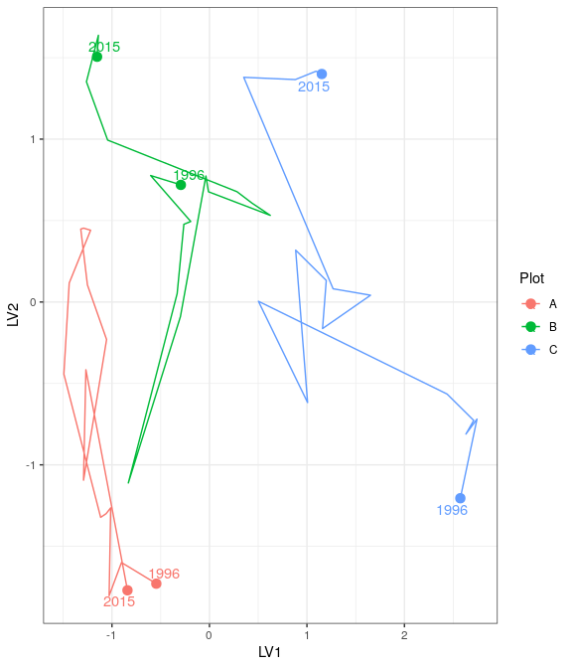

Ordination plot with full residual model on the left and a model on the right showing residual variation after the effect of groundwater levels were accounted for at the northern Joondalup transect

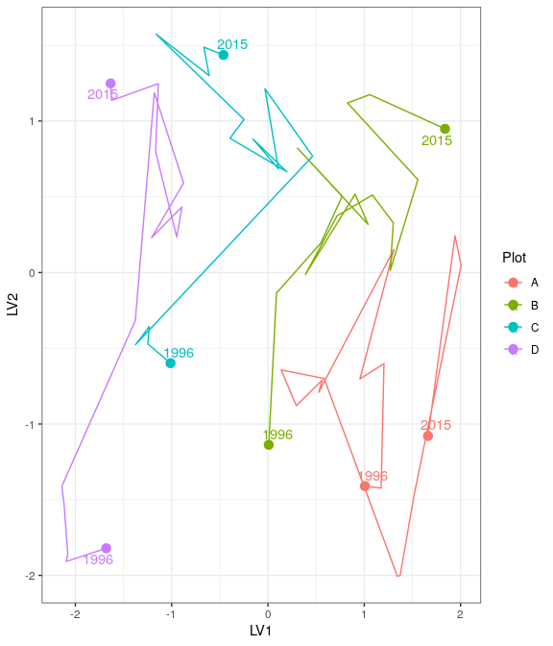

Ordination plot with full residual model on the left and a model on the right showing residual variation after the effect of groundwater levels were accounted for at the southern Joondalup transect

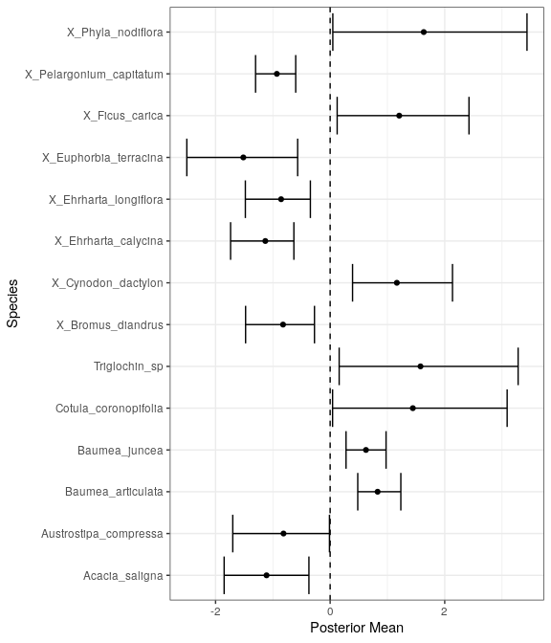

Mean regression coefficients (dots) and 95% credible intervals (bars) for effect of groundwater level on vegetation species cover abundances. Only those species with coefficients significanlty different to zero are shown

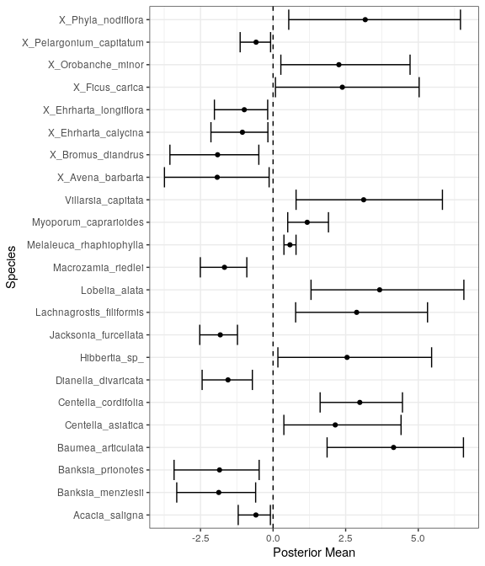

Mean regression coefficients (dots) and 95% credible intervals (bars) for effect of groundwater level on vegetation species cover abundances. Only those species with coefficients significanlty different to zero are shown

## Aquatic Invertebrates

Aquatic invertebrates have been sampled from Lake Joondalup every year since 1996. During this period, 16-30 families of aquatic invertebrates have been recorded per sampling event, except for the latest round in 2018 where family richness was only nine. This exceptionally low family richness was likely due to the lack of insects and associated parasitic mites among the sampled communities. The phreatoicid isopod Amphisopus palustris was also absent in 2018 despite being collected every spring in Lake Joondalup (expect 2004). Furthermore, this reduced richness occurred during a period of relatively high surface water levels, suggesting other anthropogenic factors may be responsible for the decline of insect fauna within the lake. Otherwise, the lake hosts abundant populations of Ceinidae (amphipods), Palaemonetes australis (crustacean), Calanoid copepods and Cyprididae (ostracods). [ANALYSE INVERTS HERE]

## Revised water level threshold effects

[Insert plot of future changes in groundwater]

The water levels in the vicinity of Lake Joondalup are expected to increase upto 2.1m by 2030 from 2013 levels based on the revised groundwater allocations. This increase in water level will continue the increasing trend being observed in the lake?s surface water levels since 2015. Maintaining surface water levels above 16.2mAHD at staff 6162572 will ensure permanent water habitat for fauna and flora and the visual amenity of the area. The diverse macrophytes inhabiting plot A and B of both transects are likely to persist and continue to provide a rich habitat for aquatic vertebrates. Although important native macrophytes and wetland species are likely to continue at relatively high cover abundances under the future scenario, there is a high proportion of exotic taxonomic richness at these sites that the model presented here does not associate with groundwater levels. The contribution of exotic species is likely associated with climatic factors and landscape changes and under the 2030 proposed groundwater thresholds, they will likely to continue contributing a large proportion of the taxonomic richness to the Lake Joondalup vegetation community. Further vegetation monitoring is required at these transects to determine vegetation compositional changes since 2015 to understand if the trajectory in compositional change is continuing.

Ecological consequences of revised thresholds in terms of compliance of stated site values and site management objectives.

|  |  |  |
| --- | --- | --- |
|  | Likely effect of 2030 revised thresholds | Future Compliance |
| **Site values** |  |  |
| Water bird habitat and drought refuge | The proposed increases in groundwater levels around the lake will ensure the site remains an important water bird habitat. The proposed increases will also ensure the lake is permanently inundated, which will ensure the lake is a drought refuge for water birds. | Yes |
| Diverse range of macrophytes | The current diversity of macrophytes, including B. articulata, B. juncea, C. asiatica and L. longitudinale, will continue. There is the possibility of these species extending into current terrestrial regions of the lake. | Yes |
| **Site management objectives** |  |  |
| Conservation and public enjoyment of natural and modified landscapes |  | Yes |
| Conserve existing wetland vegetation, including sedge beds, fringing woodland and aquatic macrophytes | The predicted increases in groundwater levels will ensure the current wetland at a state similar to 2015. It is possible that sustained increases in groundwater levels will extend the range of these species around the lake by ‘migrating’ upslope. | Yes |
| Maintain and if possible, enhance the aquatic fauna of the lake |  |  |
| In conjunction with Lake Goollelal, to support the full range of habitats for avian fauna | The maintenance of permanent surface water and wetland vegetation will continue to provide a diverse habitat for different avian species. [NEED TO COMMENT ON AQ INVERTS AS FOOD] | Yes |
| Ensure the landscape and amenity values of the lake are maintained, except under very low rainfall climatic conditions |  | Yes |

# Lexia 186

Five year summaries of surface water level data at Lexia 186

| Period | Mean max seasonal level (mAHD) | Mean min seasonal level (mAHD) | Mean seasonal change (m) | Month of maximum | Month of minimum | Mean max to min (days) |
| --- | --- | --- | --- | --- | --- | --- |
| 08/1994 - 07/1999 | 3.169 | 1.831 | 1.337 | September | May | 212.600 |
| 08/1999 - 07/2004 | 2.770 | 1.794 | 0.976 | October | March | 167.800 |
| 08/2004 - 07/2009 | 2.386 | 1.996 | 0.390 | September | November | 11.800 |
| 08/2009 - 07/2014 | 1.981 | 1.000 | 0.981 | October | July | 87.800 |
| 08/2014 - 07/2019 | 1.967 | 1.000 | 0.967 | September | January | 124.400 |

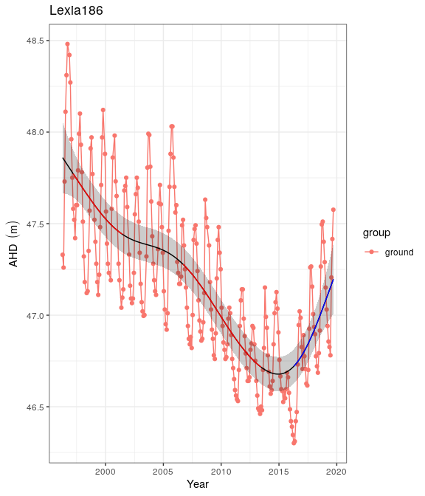

Ground and surface water levels recorded at bores and staff gauges in the vicinity of Lexia 186

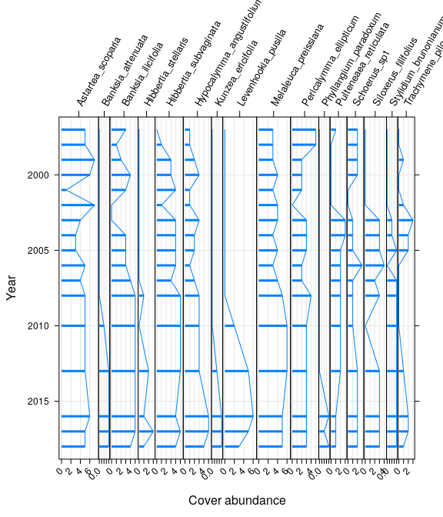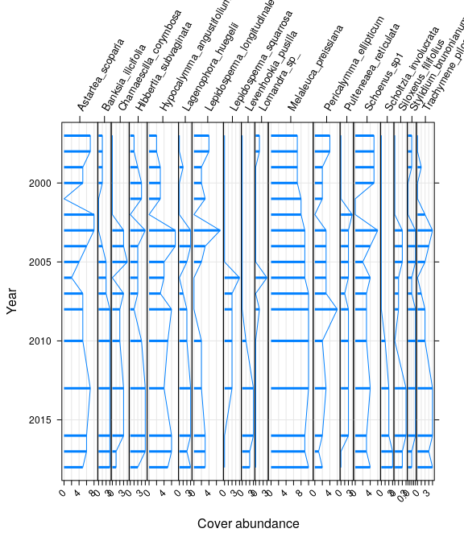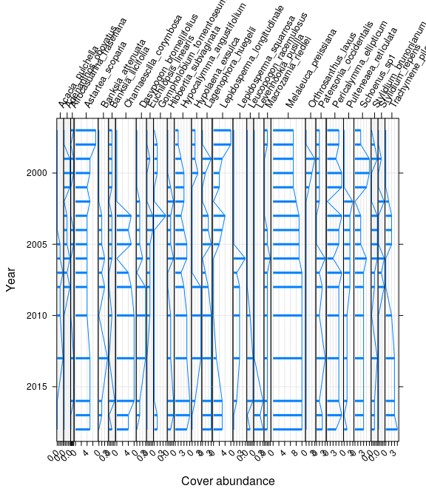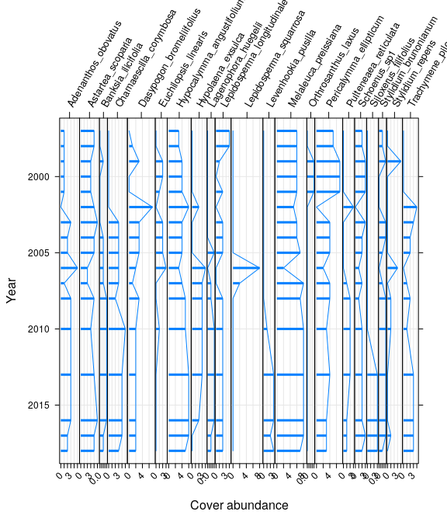

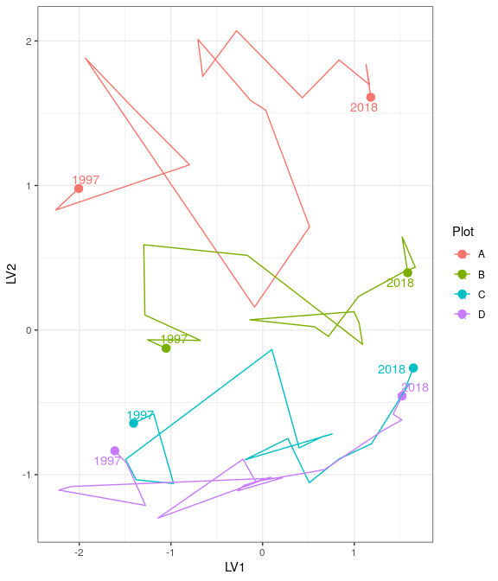

Ordination plot with full residual model on the left and a model on the right showing residual variation after the effect of groundwater levels were accounted for

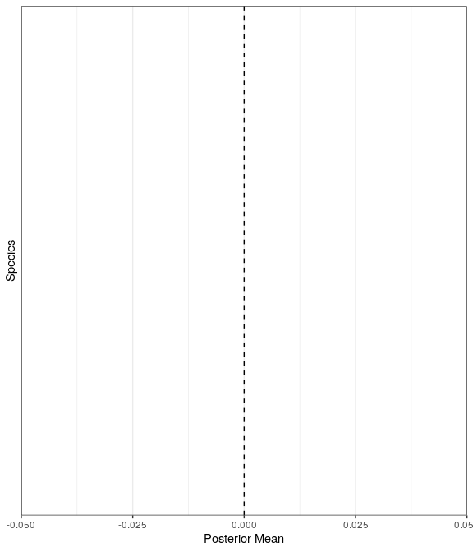

Mean regression coefficients (dots) and 95% credible intervals (bars) for effect of groundwater level on vegetation species cover abundances. Only those species with coefficients significanlty different to zero are shown

# Loch McNess

Five year summaries of surface water level data at Loch McNess

| Period | Mean max seasonal level (mAHD) | Mean min seasonal level (mAHD) | Mean seasonal change (m) | Month of maximum | Month of minimum | Mean max to min (days) |
| --- | --- | --- | --- | --- | --- | --- |
| 08/1994 - 07/1999 | 7.107 | 6.997 | 0.110 | September | March | 123.200 |
| 08/1999 - 07/2004 | 7.067 | 6.944 | 0.123 | July | March | 91.000 |
| 08/2004 - 07/2009 | 6.969 | 6.762 | 0.207 | June | February | 131.200 |
| 08/2009 - 07/2014 | 6.532 | 6.220 | 0.312 | October | May | 229.000 |
| 08/2014 - 07/2019 | 6.250 | 6.140 | 0.110 | December | July | 25.000 |

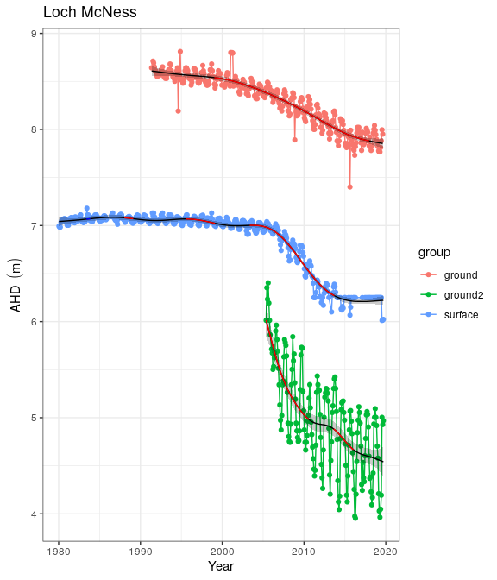

Ground and surface water levels recorded at bores and staff gauges in the vicinity of Loch McNess

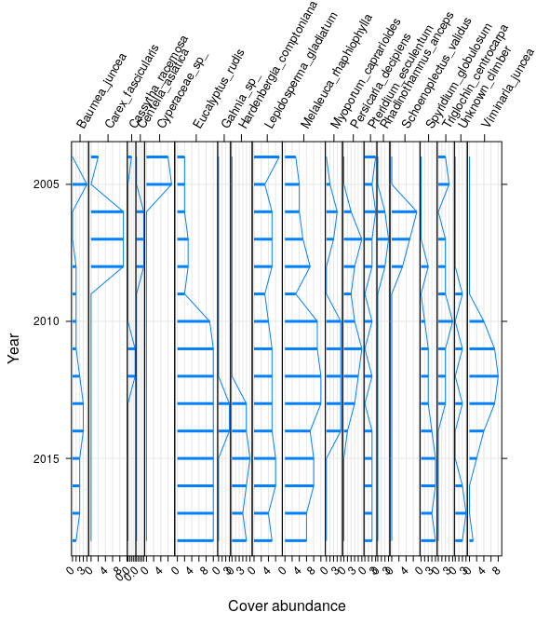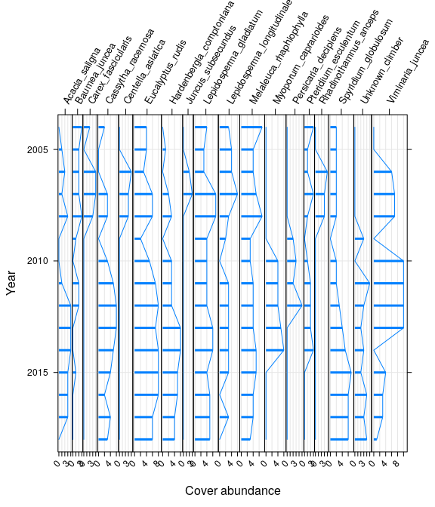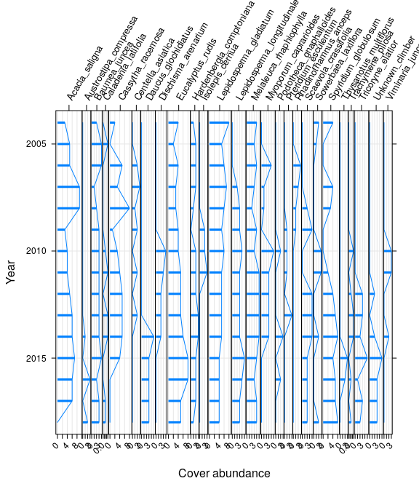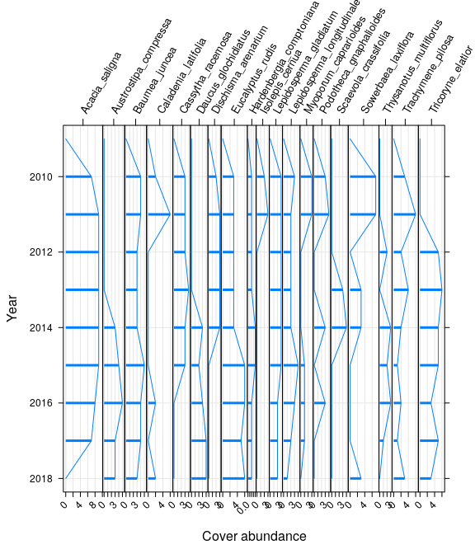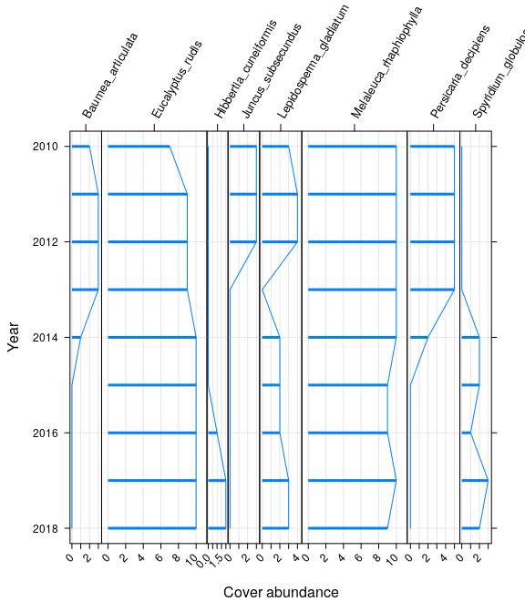

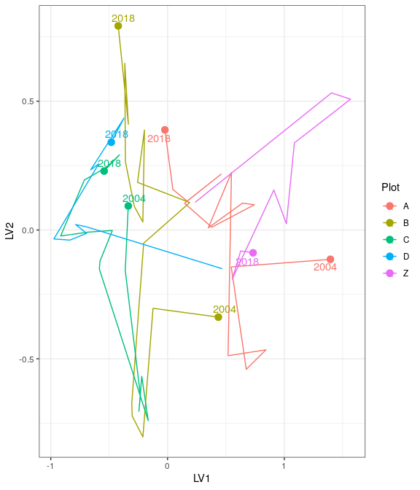

Ordination plot with full residual model on the left and a model on the right showing residual variation after the effect of groundwater levels were accounted for

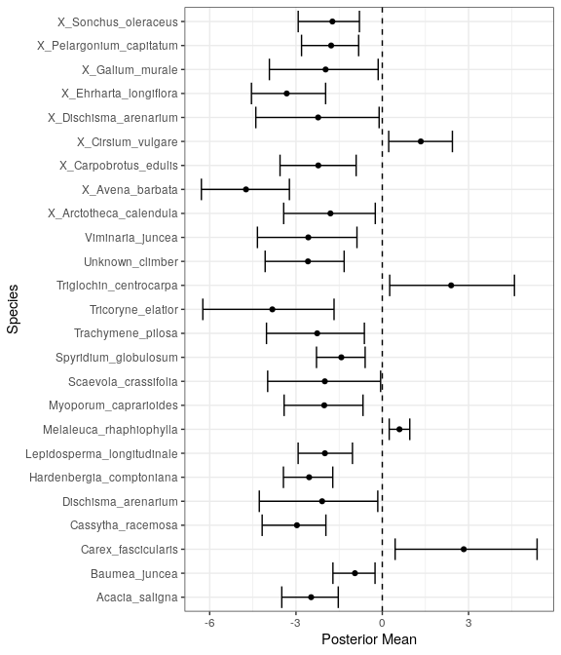

Mean regression coefficients (dots) and 95% credible intervals (bars) for effect of groundwater level on vegetation species cover abundances. Only those species with coefficients significanlty different to zero are shown

# Mariginiup

Five year summaries of surface water level data at Mariginiup

| Period | Mean max seasonal level (mAHD) | Mean min seasonal level (mAHD) | Mean seasonal change (m) | Month of maximum | Month of minimum | Mean max to min (days) |
| --- | --- | --- | --- | --- | --- | --- |
| 08/1994 - 07/1999 | 41.997 | 41.190 | 0.807 | September | February | 175.600 |
| 08/1999 - 07/2004 | 41.791 | 41.286 | 0.505 | October | July | 135.600 |
| 08/2004 - 07/2009 | 41.484 | 41.274 | 0.210 | September | July | 111.600 |
| 08/2009 - 07/2014 | 41.254 | 41.066 | 0.188 | October | January | 21.400 |
| 08/2014 - 07/2019 | 41.395 | 41.000 | 0.395 | September | January | 133.800 |

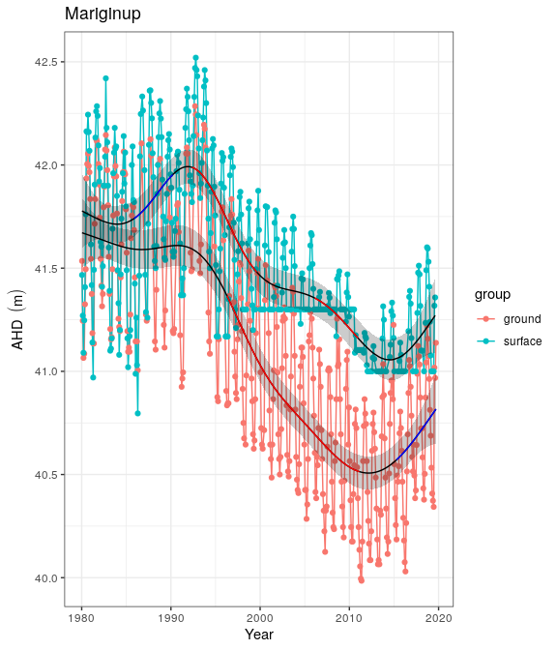

Ground and surface water levels recorded at bores and staff gauges in the vicinity of Mariginiup

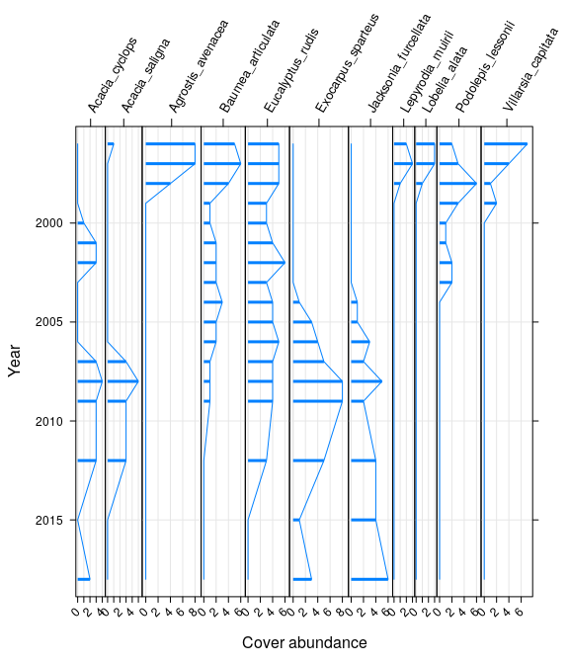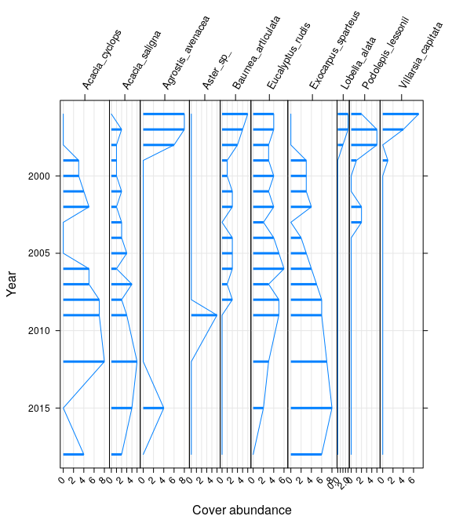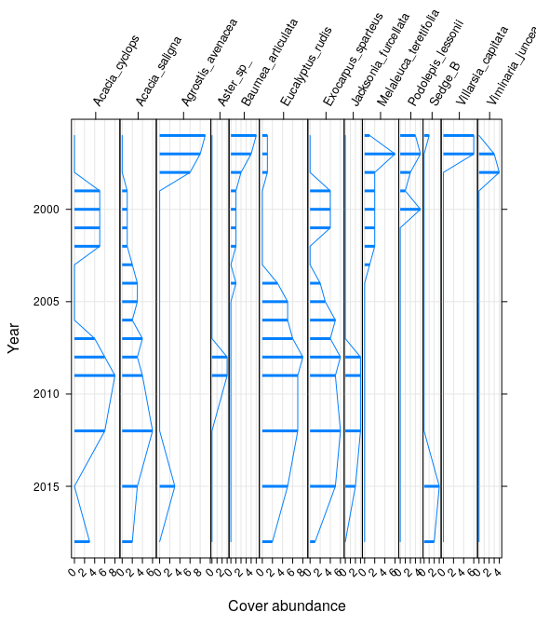

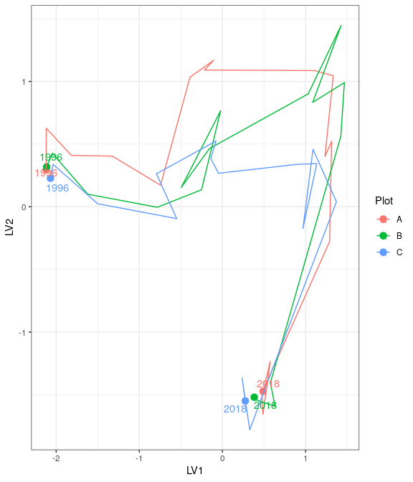

Ordination plot with full residual model on the left and a model on the right showing residual variation after the effect of groundwater levels were accounted for

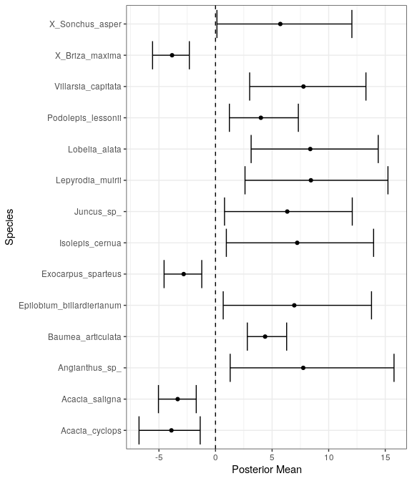

Mean regression coefficients (dots) and 95% credible intervals (bars) for effect of groundwater level on vegetation species cover abundances. Only those species with coefficients significanlty different to zero are shown

# MM59B

Five year summaries of surface water level data at MM59B

| Period | Mean max seasonal level (mAHD) | Mean min seasonal level (mAHD) | Mean seasonal change (m) | Month of maximum | Month of minimum | Mean max to min (days) |
| --- | --- | --- | --- | --- | --- | --- |
| 08/1994 - 07/1999 | 18.880 | 18.002 | 0.878 | September | May | 221.200 |
| 08/1999 - 07/2004 | 18.614 | 17.794 | 0.820 | October | April | 188.400 |
| 08/2004 - 07/2009 | 18.606 | 17.926 | 0.680 | October | March | 144.000 |
| 08/2009 - 07/2014 | 18.768 | 18.079 | 0.689 | October | May | 205.600 |
| 08/2014 - 07/2019 | 19.036 | 18.439 | 0.597 | September | April | 223.800 |

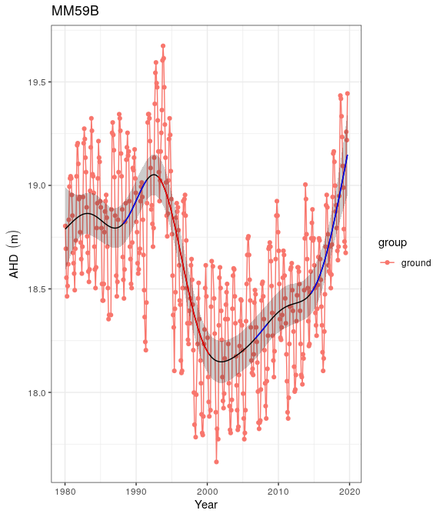

Ground and surface water levels recorded at bores and staff gauges in the vicinity of MM59B

# Nowergup

Five year summaries of surface water level data at Nowergup

| Period | Mean max seasonal level (mAHD) | Mean min seasonal level (mAHD) | Mean seasonal change (m) | Month of maximum | Month of minimum | Mean max to min (days) |
| --- | --- | --- | --- | --- | --- | --- |
| 08/1994 - 07/1999 | 17.005 | 16.166 | 0.839 | October | May | 114.800 |
| 08/1999 - 07/2004 | 16.687 | 15.964 | 0.723 | October | May | 20.400 |
| 08/2004 - 07/2009 | 16.777 | 16.216 | 0.561 | October | September | -1.400 |
| 08/2009 - 07/2014 | 16.161 | 15.988 | 0.173 | September | December | 78.800 |
| 08/2014 - 07/2019 | 16.000 | 15.615 | 0.385 | September | November | 56.400 |

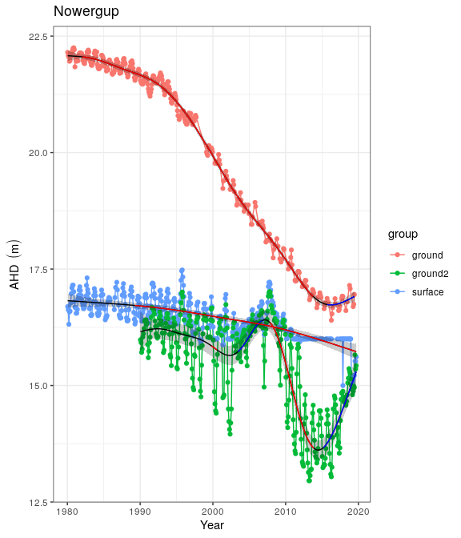

Ground and surface water levels recorded at bores and staff gauges in the vicinity of Nowergup

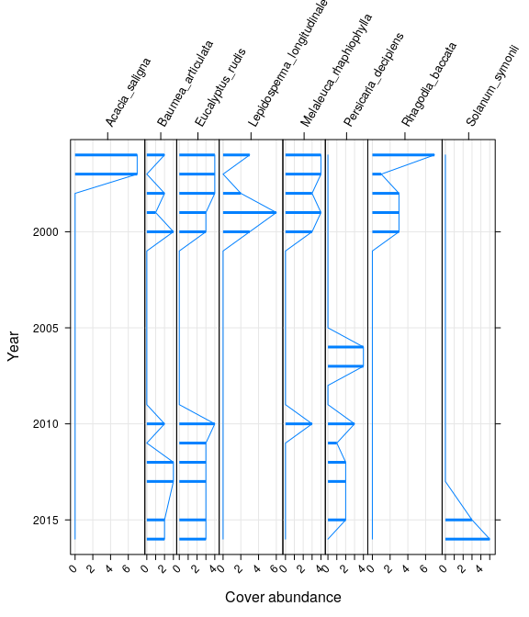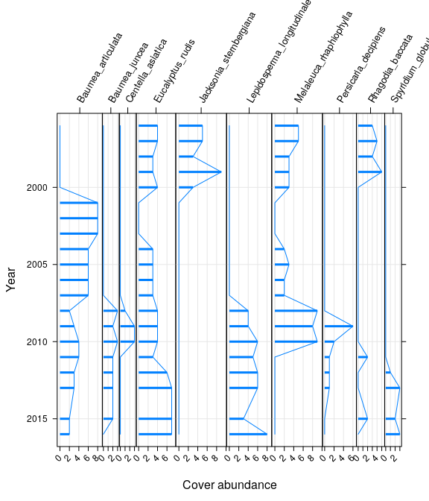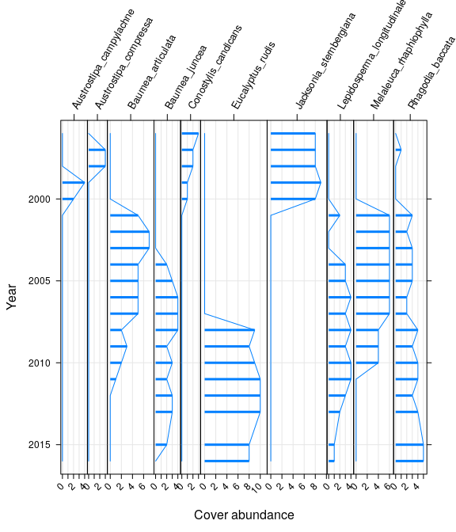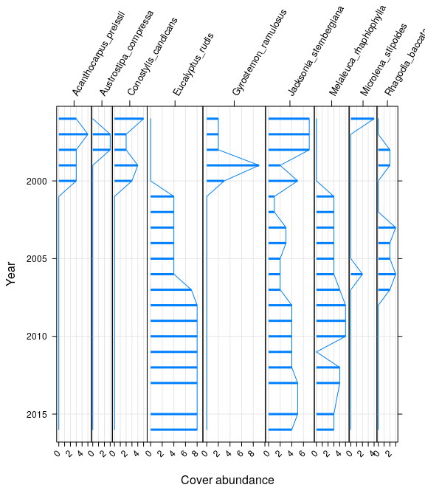

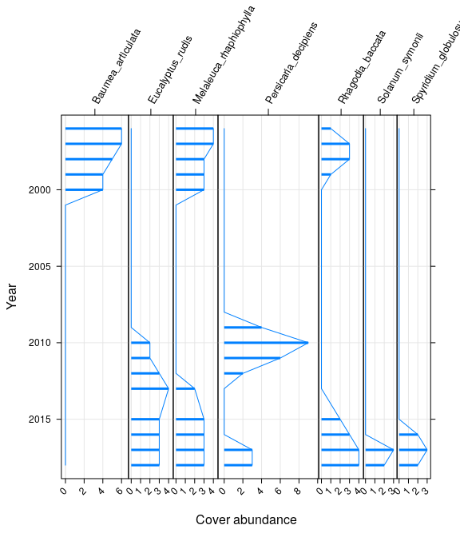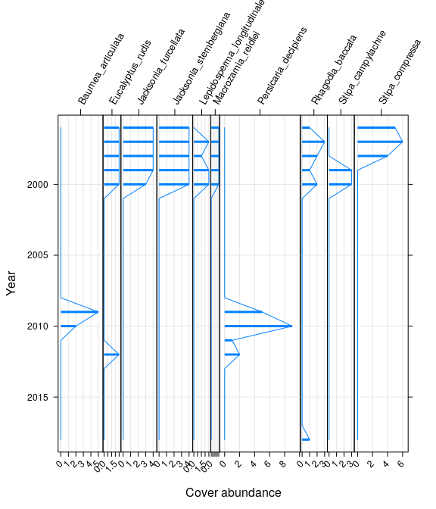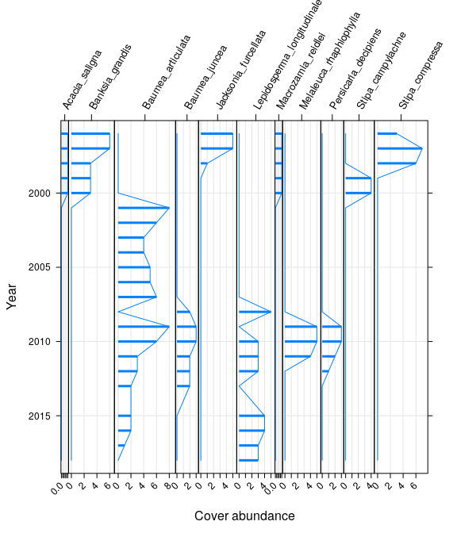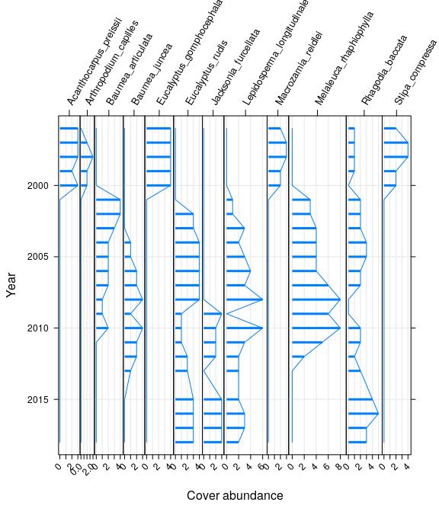

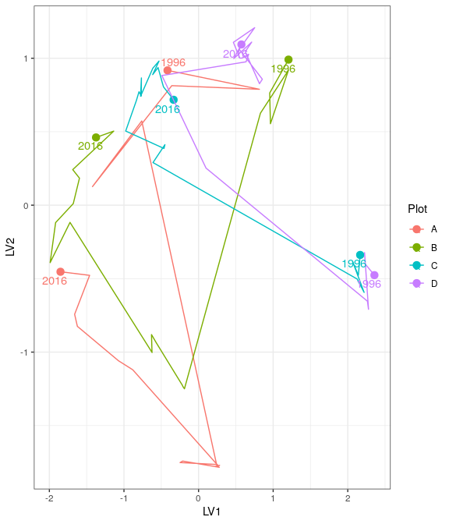

Ordination plot with full residual model on the left and a model on the right showing residual variation after the effect of groundwater levels were accounted for

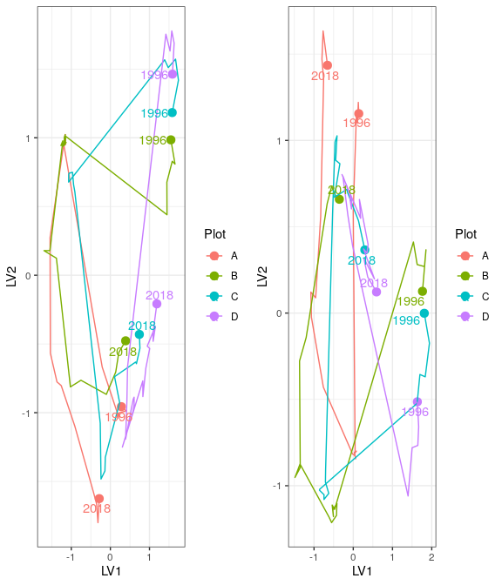

Ordination plot with full residual model on the left and a model on the right showing residual variation after the effect of groundwater levels were accounted for

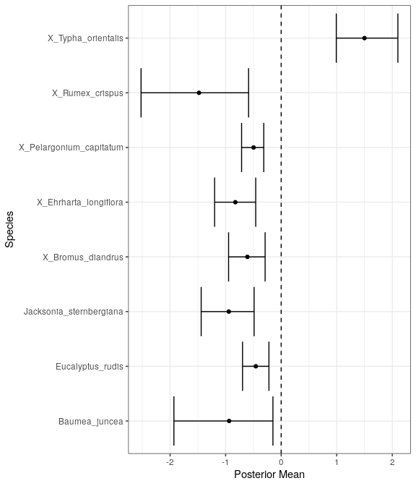

Mean regression coefficients (dots) and 95% credible intervals (bars) for effect of groundwater level on vegetation species cover abundances. Only those species with coefficients significanlty different to zero are shown

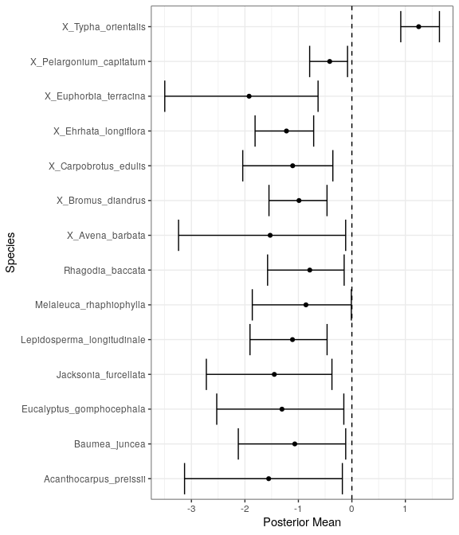

Mean regression coefficients (dots) and 95% credible intervals (bars) for effect of groundwater level on vegetation species cover abundances. Only those species with coefficients significanlty different to zero are shown

# Pipidinny

Five year summaries of surface water level data at Pipidinny

| Period | Mean max seasonal level (mAHD) | Mean min seasonal level (mAHD) | Mean seasonal change (m) | Month of maximum | Month of minimum | Mean max to min (days) |
| --- | --- | --- | --- | --- | --- | --- |
| 08/1994 - 07/1999 | 3.169 | 1.831 | 1.337 | September | May | 212.600 |
| 08/1999 - 07/2004 | 2.770 | 1.794 | 0.976 | October | March | 167.800 |
| 08/2004 - 07/2009 | 2.386 | 1.996 | 0.390 | September | November | 11.800 |
| 08/2009 - 07/2014 | 1.981 | 1.000 | 0.981 | October | July | 87.800 |
| 08/2014 - 07/2019 | 1.967 | 1.000 | 0.967 | September | January | 124.400 |

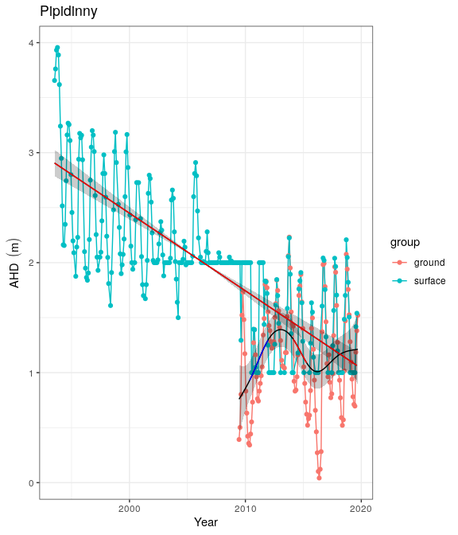

Ground and surface water levels recorded at bores and staff gauges in the vicinity of Pipidinny

# PM9

Five year summaries of surface water level data at PM9

| Period | Mean max seasonal level (mAHD) | Mean min seasonal level (mAHD) | Mean seasonal change (m) | Month of maximum | Month of minimum | Mean max to min (days) |
| --- | --- | --- | --- | --- | --- | --- |
| 08/1994 - 07/1999 | 58.436 | 57.708 | 0.728 | November | June | 251.600 |
| 08/1999 - 07/2004 | 57.500 | 56.822 | 0.678 | September | July | 201.200 |
| 08/2004 - 07/2009 | 56.516 | 56.022 | 0.494 | October | July | 256.800 |
| 08/2009 - 07/2014 | 55.179 | 54.738 | 0.441 | November | September | 206.600 |
| 08/2014 - 07/2019 | 54.385 | 52.830 | 1.555 | December | May | 242.500 |

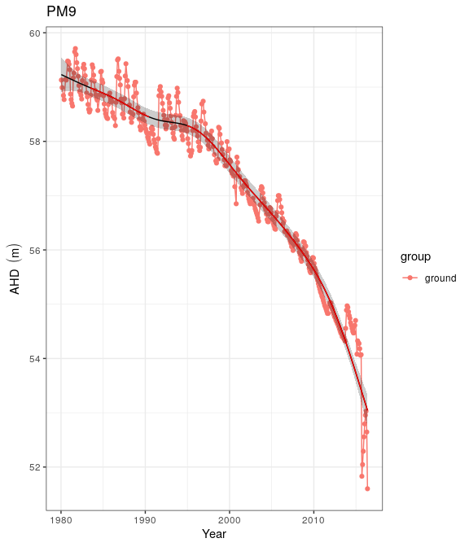

Ground and surface water levels recorded at bores and staff gauges in the vicinity of PM9

# Quin Brook

Five year summaries of surface water level data at Quin Brook

| Period | Mean max seasonal level (mAHD) | Mean min seasonal level (mAHD) | Mean seasonal change (m) | Month of maximum | Month of minimum | Mean max to min (days) |
| --- | --- | --- | --- | --- | --- | --- |
| 08/1994 - 07/1999 | 59.032 | 58.774 | 0.258 | January | July | 125.200 |
| 08/1999 - 07/2004 | 58.224 | 58.064 | 0.160 | January | April | 93.400 |
| 08/2004 - 07/2009 | 57.109 | 56.864 | 0.245 | October | April | 203.200 |
| 08/2009 - 07/2014 | 55.572 | 55.430 | 0.142 | November | April | 196.000 |
| 08/2014 - 07/2019 | 54.122 | 54.013 | 0.109 | October | October | 47.200 |

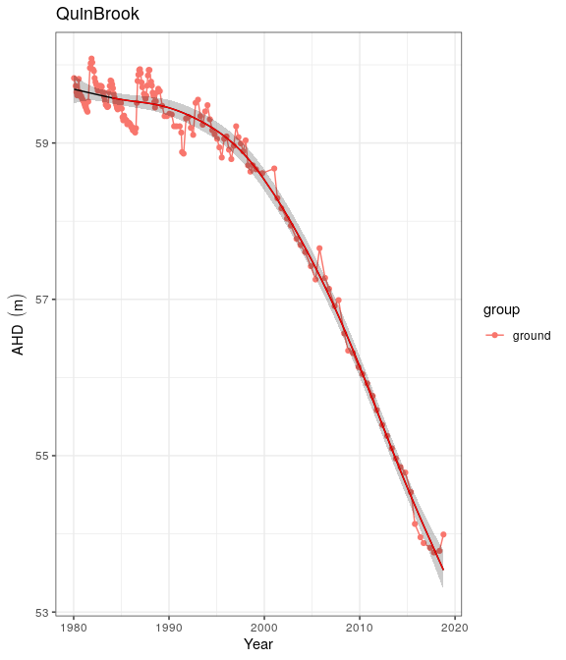

Ground and surface water levels recorded at bores and staff gauges in the vicinity of Quin Brook

# Wilgarup

Five year summaries of surface water level data at Wilgarup

| Period | Mean max seasonal level (mAHD) | Mean min seasonal level (mAHD) | Mean seasonal change (m) | Month of maximum | Month of minimum | Mean max to min (days) |
| --- | --- | --- | --- | --- | --- | --- |
| 08/1994 - 07/1999 | 5.220 | 4.310 | 0.910 | October | March | 184.500 |
| 08/1999 - 07/2004 | 4.745 | 4.017 | 0.728 | October | April | 193.400 |
| 08/2004 - 07/2009 | 4.327 | 3.705 | 0.622 | September | May | 150.000 |
| 08/2009 - 07/2014 | 3.816 | 3.222 | 0.594 | October | April | 190.400 |
| 08/2014 - 07/2019 | 3.632 | 3.085 | 0.547 | October | May | 212.400 |

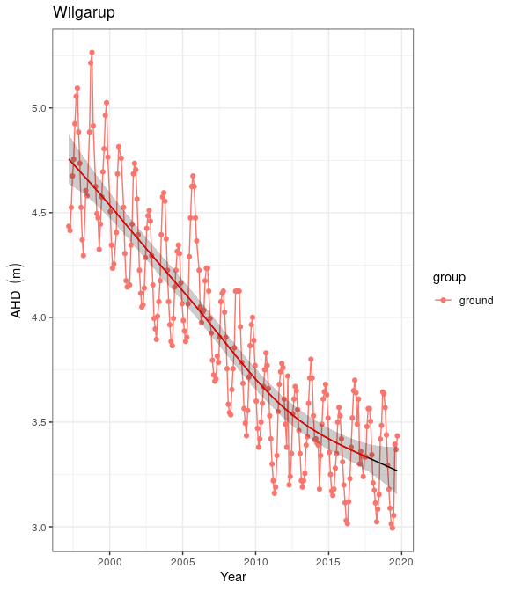

Ground and surface water levels recorded at bores and staff gauges in the vicinity of Wilgarup

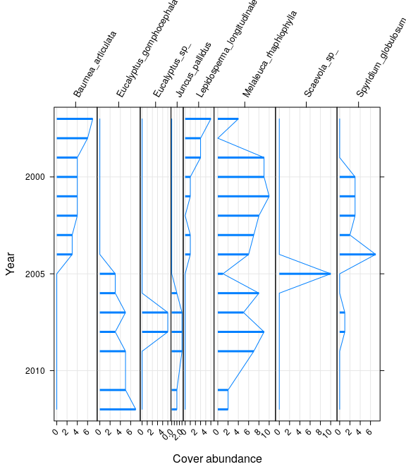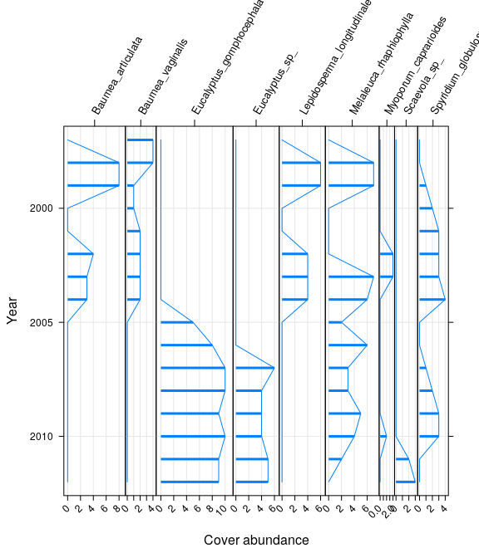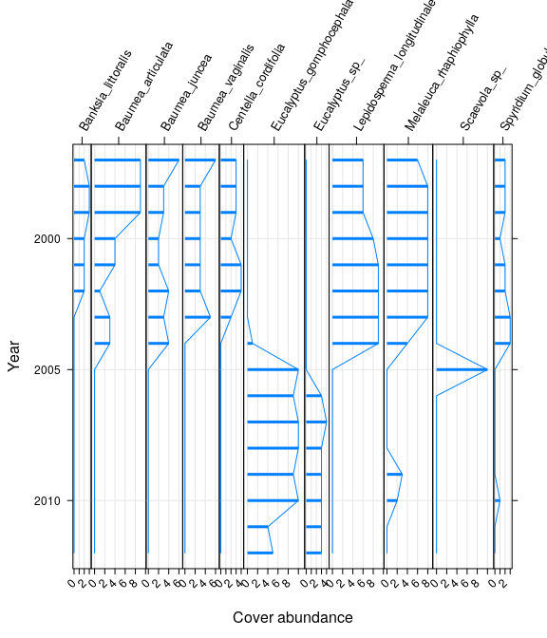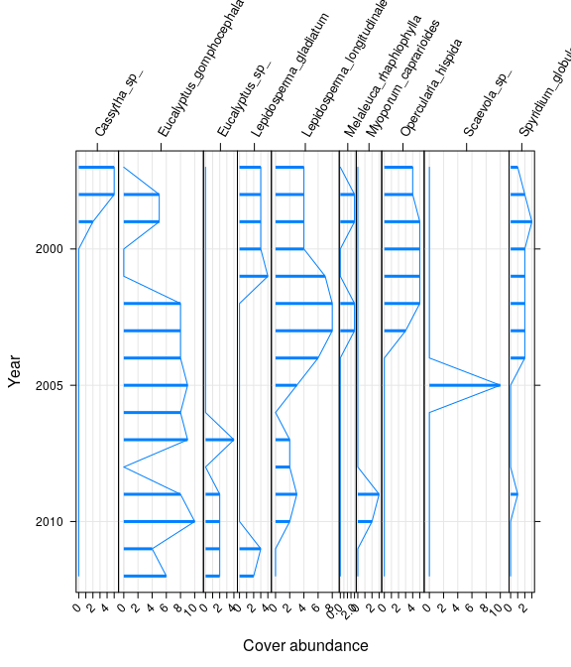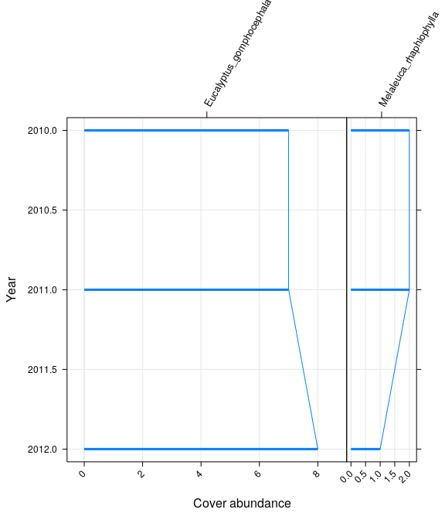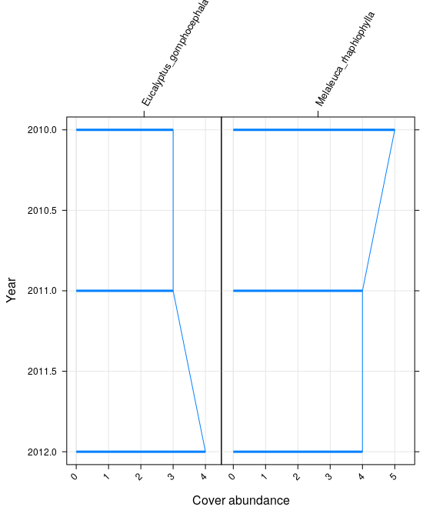

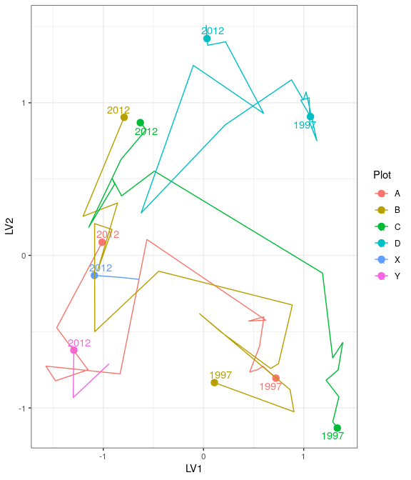

Ordination plot with full residual model on the left and a model on the right showing residual variation after the effect of groundwater levels were accounted for

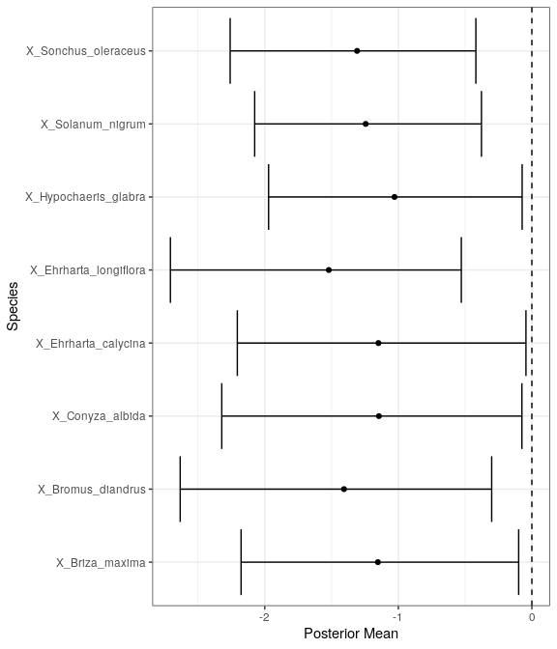

Mean regression coefficients (dots) and 95% credible intervals (bars) for effect of groundwater level on vegetation species cover abundances. Only those species with coefficients significanlty different to zero are shown

# WM1

Five year summaries of surface water level data at EMP 173

| Period | Mean max seasonal level (mAHD) | Mean min seasonal level (mAHD) | Mean seasonal change (m) | Month of maximum | Month of minimum | Mean max to min (days) |
| --- | --- | --- | --- | --- | --- | --- |
| 08/1994 - 07/1999 | 51.122 | 50.209 | 0.913 | October | March | 195.667 |
| 08/1999 - 07/2004 | 51.086 | 50.410 | 0.676 | September | April | 157.600 |
| 08/2004 - 07/2009 | 51.036 | 50.410 | 0.626 | August | January | 79.000 |
| 08/2009 - 07/2014 | 50.732 | 50.400 | 0.332 | October | February | 60.800 |
| 08/2014 - 07/2019 | 50.804 | 50.400 | 0.404 | September | January | 85.600 |

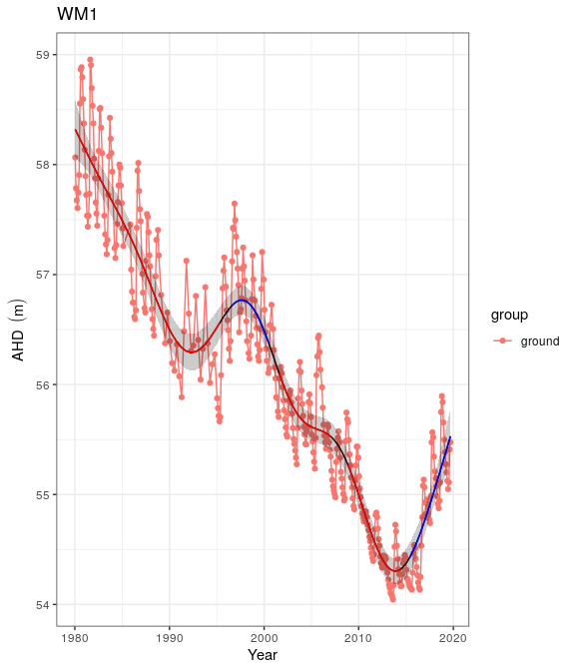

Ground and surface water levels recorded at bores and staff gauges in the vicinity of WM1

# WM2

Five year summaries of surface water level data at WM2

| Period | Mean max seasonal level (mAHD) | Mean min seasonal level (mAHD) | Mean seasonal change (m) | Month of maximum | Month of minimum | Mean max to min (days) |
| --- | --- | --- | --- | --- | --- | --- |
| 08/1994 - 07/1999 | 51.122 | 50.209 | 0.913 | October | March | 195.667 |
| 08/1999 - 07/2004 | 51.086 | 50.410 | 0.676 | September | April | 157.600 |
| 08/2004 - 07/2009 | 51.036 | 50.410 | 0.626 | August | January | 79.000 |
| 08/2009 - 07/2014 | 50.732 | 50.400 | 0.332 | October | February | 60.800 |
| 08/2014 - 07/2019 | 50.804 | 50.400 | 0.404 | September | January | 85.600 |

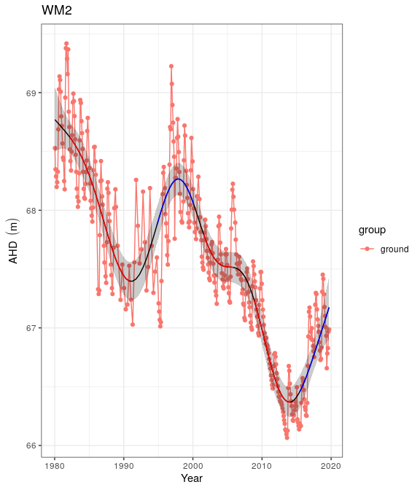

Ground and surface water levels recorded at bores and staff gauges in the vicinity of WM2

# WM8

Five year summaries of surface water level data at WM8

| Period | Mean max seasonal level (mAHD) | Mean min seasonal level (mAHD) | Mean seasonal change (m) | Month of maximum | Month of minimum | Mean max to min (days) |
| --- | --- | --- | --- | --- | --- | --- |
| 08/1994 - 07/1999 | 66.313 | 65.661 | 0.652 | October | July | 230.200 |
| 08/1999 - 07/2004 | 66.013 | 65.485 | 0.528 | December | June | 180.000 |
| 08/2004 - 07/2009 | 65.609 | 65.209 | 0.400 | November | July | 256.000 |
| 08/2009 - 07/2014 | 65.007 | 64.651 | 0.356 | November | August | 200.200 |
| 08/2014 - 07/2019 | 65.029 | 64.703 | 0.326 | December | July | 29.600 |

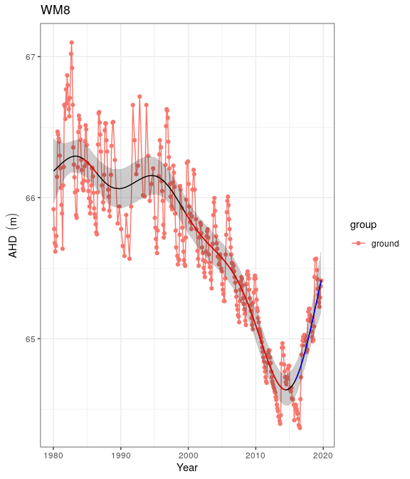

Ground and surface water levels recorded at bores and staff gauges in the vicinity of WM8

# Yonderup

Five year summaries of surface water level data at Yonderup

| Period | Mean max seasonal level (mAHD) | Mean min seasonal level (mAHD) | Mean seasonal change (m) | Month of maximum | Month of minimum | Mean max to min (days) |
| --- | --- | --- | --- | --- | --- | --- |
| 08/1994 - 07/1999 | 5.993 | 5.924 | 0.069 | August | September | 82.400 |
| 08/1999 - 07/2004 | 5.959 | 5.901 | 0.058 | September | February | 143.600 |
| 08/2004 - 07/2009 | 5.921 | 5.862 | 0.059 | April | April | 130.200 |
| 08/2009 - 07/2014 | 5.867 | 5.681 | 0.186 | September | April | 211.800 |
| 08/2014 - 07/2019 | 5.808 | 5.557 | 0.251 | September | March | 218.400 |

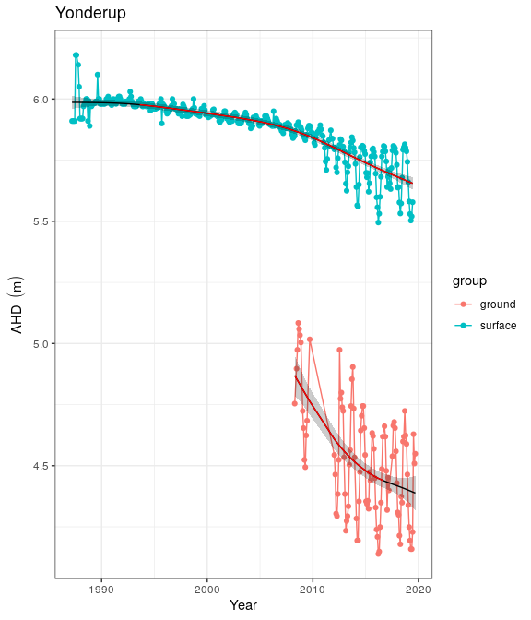

Ground and surface water levels recorded at bores and staff gauges in the vicinity of Yonderup

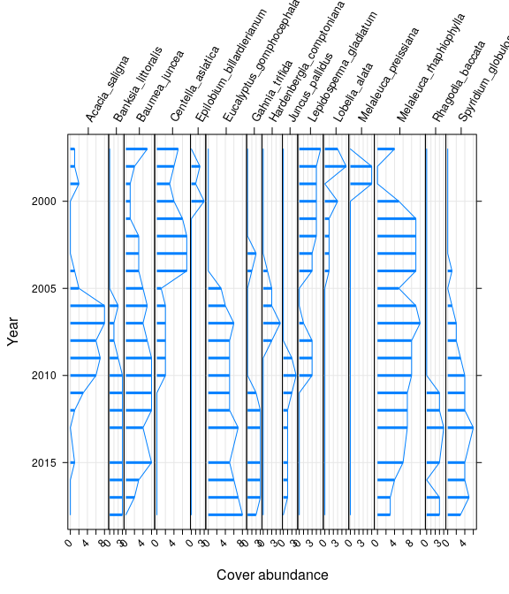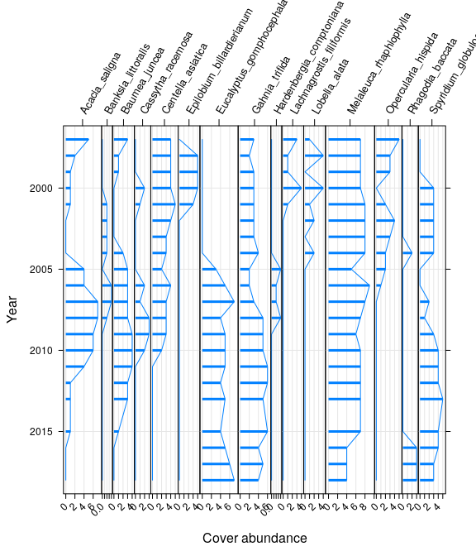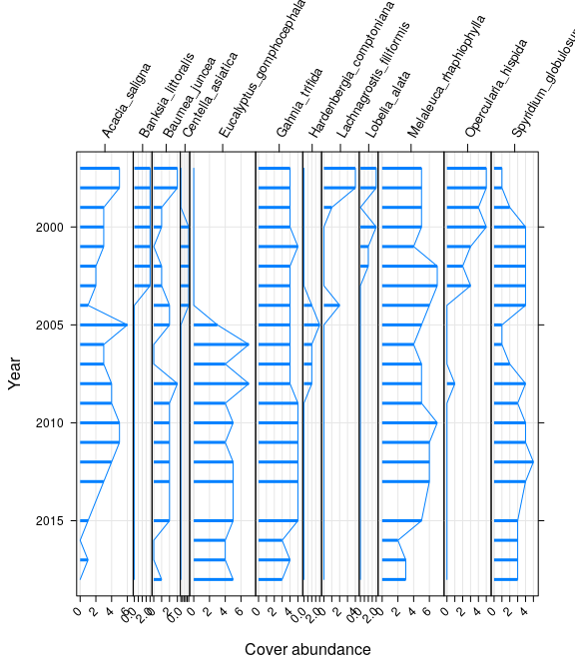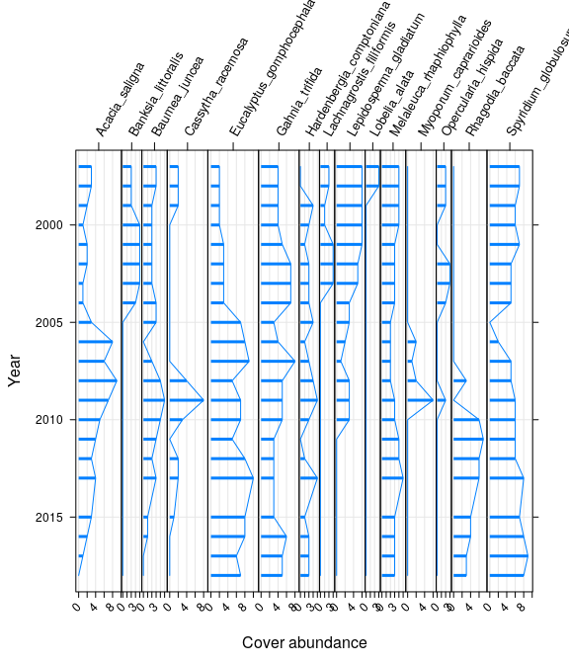

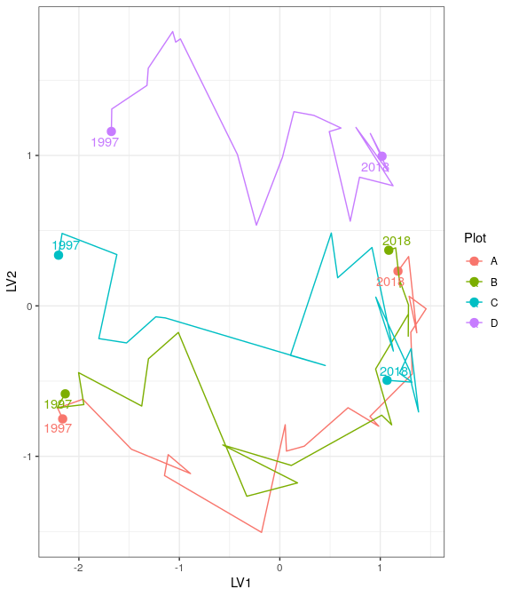

Ordination plot with full residual model on the left and a model on the right showing residual variation after the effect of groundwater levels were accounted for

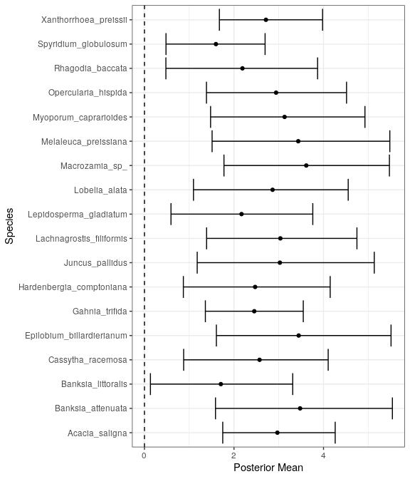

Mean regression coefficients (dots) and 95% credible intervals (bars) for effect of groundwater level on vegetation species cover abundances. Only those species with coefficients significanlty different to zero are shown